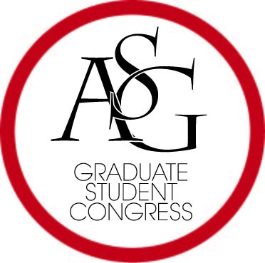
Graduate Student Congress
Associated Student Government
University of Arkansas

Graduate Student Congress Awards Application

Rules of Applying
- Application period: March 15 – April 1
- Application deadline: April 1, 11:59PM.
- Indicate for which award you are nominating. One nomination per application.
- Application must be emailed to the Graduate Student Congress Treasurer, asggctrs@uark.edu
- Notifications: One week before the final GSC meeting of the year.

Qualifications
- Accomplishments that qualify an individual for an award must have taken within the award year defined as running from April 2 to April 1 of the following year.
- Additionally individuals are only eligible for own Award in each category per “award year”
- These nominations may be self-nominated/reported.
- Applicants must also provide evidence to support for their application.

The Application

- Award for which individual is being nominated:

- Name of nominee, college, department, and program (Ma, PhD, JD):

- Contact information of the nominee:

- Name of individual putting forth nomination:
(Although you may put forth a nomination for each award, you may not nominate more than one person for any individual award.)

- Please attach a brief statement as to why the nominated should be considered for this honor with your email containing this application cover sheet.

- Please attach any supporting documents, journal articles, news stories, etc.

Descriptions of the GSC Awards:
- Alex Marino Service Award
  - Open to any Graduate Student
  - Awarded to one Graduate Student that has provided outstanding service to their department, college, the University of Arkansas, or within the broader community within the current academic year.
- Research Award
  - Open to any Graduate Student
  - Awarded to one Graduate student engaged in outstanding academic research, regardless of department, that has caused honor to be bestowed upon said individual and graduate programs at the University of Arkansas within the current academic year.
- Faculty Ally of the Year Award
  - Open to any University of Arkansas Faculty Member
  - Awarded to one University Faculty Member who has proved through guidance, support, word, or deed to be a steadfast ally to the Graduate Student Congress and Graduate Students in general at the University of Arkansas within the current academic year.
- Staff Ally of the Year Award
  - Open to any University of Arkansas Staff Member
  - Awarded to one University of Arkansas staff member who has proved through guidance, support, word, or deed to be a steadfast ally to the Graduate Student Congress and Graduate Students in general to the University of Arkansas within the current academic year.
- Administration Ally of the Year Award
  - Open to any member of Administration at the University of Arkansas
  - Awarded to one member of Administration at the University of Arkansas who has shown through guidance, support, word, or deed to be a steadfast ally to the Graduate Student Congress and Graduate Students in general at the University of Arkansas within the current academic year.
- Community Ally of the Year Award
  - Open to any community member from Fayetteville, or Northwest Arkansas.
  - Awarded to one community member from the broader Fayetteville community who has proved through guidance, support, word or deed to be a steadfast ally to Graduate Students at the University of Arkansas.
- Civic Ally of the Year Award
  - Open to any elected official – city, county, state, or national.
  - Awarded to one elected official who had proved through guidance, support, word, or deed to be committed to hearing the concerns of Graduate Students, drafting, passing, of enforcing legislation to improve the lives of Graduate Students
- Graduate Student Congress Outreach Award
  - Open to any Graduate Student Congress member who has proved through guidance, support, word, or deed to be exceptionally dedicated to the advancement of causes important to Graduate Students and the reputation the Graduate Student Congress.
- Garret Jeter, Veteran of the Year Award
  - Open to any graduate or professional veteran.
  - Awarded to one veteran who has crucial to the graduate community through word, deed, and service at the University of Arkansas, Fayetteville.

The Excellence in Graduate Education Awards
- Graduate-Professional Student Government Service
  - Awarded to students who have authored legislation, and/or served as a Committee Chair and/of served as a caucus Chair, and/or engaged in campus outreach above and beyond their normal duties as a Graduate Student representative.
- Campus Leadership
  - Awarded to students who have undertaken, led or advocated for a cause, project, or program designed to benefit graduates students, served on a university-wide committee, or logged more than fifty (50) community service house through the Volunteer Action Center as tracked by GivePulsa; and,
- Academic Prowess
  - Candidates being recognized for Academic Prowess shall have won a competitive grant, scholarship, or fellowship at the local, state, regional, national, or global level or have had academic work published either in print or electronically.

