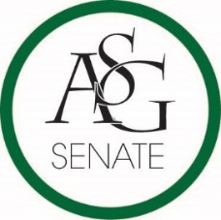
Senate Agenda
January 22nd, 2019
Graduate Education Auditorium, 6:00 PM
- Call to Order
- Roll Call
- Approval of the Minutes
- Special Orders
  - Reports (5 minutes each)
    - Special Reports
    - Advisor, PJ Martinez
    - Graduate Assistants, Joshua Saraping and Sage McCoy
    - President, J.P. Gairhan
    - Vice-President, Abigail Walker
    - Treasurer, Isamar Garcia
    - Secretary, Luke Humphrey
    - Chief Justice, Julianna Tidwell
    - GSC President, Arley Ward
    - Cabinet Reports
      - Chief of Staff, Carus Newman
    - FLF Coordinator, Will Clark
    - Chair of the Senate, Colman Betler
- Appointments, Nominations, and Elections
  - Conformation of Jordan Harmon
- Public Comment (3 at 2 minutes each)
- Old Business
  - ASG Senate Resolution No. 6- A Resolution to A Resolution Supporting Student Concessions Specials at Athletic Events
    - Authors: Senator Kianna Sarvestani, ASG Director of Athletics John Hedgecock, ASG Deputy Director Addison Cathey
    - Sponsors: Senator Cassidy Cook, Senator Sydney Belt, Senator Natalie Ceniceros,
- New Business
- Announcements
- Adjournment

