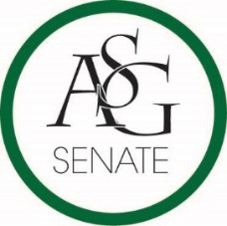
Senate Agenda
October 2nd, 2018
Graduate Education Auditorium, 6:00 PM
- Call to Order
- Roll Call
- Approval of the Minutes
- Special Orders
  - Reports (5 minutes each)
    - Special Reports
    - Advisor, Mary Skinner
    - Graduate Assistants, Joshua Saraping and Sage McCoy
    - President, J.P. Gairhan
      - ASG Constitution Update Proposal
      - ASG Code Update Proposal
    - Vice-President, Abigail Walker
    - Treasurer, Isamar Garcia
      - ASG Budget Approval
    - Secretary, Luke Humphrey
    - Chief Justice, Julianna Tidwell
      - Justice confirmation
    - GSC Speaker, Arley Ward
    - Cabinet Reports
      - Chief of Staff, Carus Newman
    - FLF Coordinator, Will Clark
    - Chair of the Senate, Colman Betler
- Appointments, Nominations, and Elections
  - Campus Council Appointments
- Public Comment (3 at 2 minutes each)
- Old Business
- New Business
  - ASG Senate Resolution No. 1 - A Resolution to Support the Re-drafting of University Absence Policy
    - Authored by Senator Cassidy Cook and Senator Kianna Sarvestani
    - Sponsored by Senator Olivia Chambers and Senator Katelyn Collison
  - ASG Senate Resolution No. 2 - A Resolution to Support the Expansion of the Title IX Office
    - Authored by Senator Daniel Webster and Director of Safety Maria Calderon
    - Sponsored by Senator Hope Davenport, Senator Samantha Gregory, and Senator Katie Gardner
- Announcements
- Adjournment

