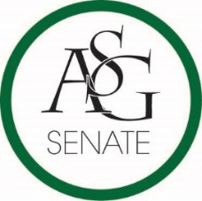
Senate Agenda
November 6th, 2018
Graduate Education Auditorium, 6:00 PM
- Call to Order
- Roll Call
- Approval of the Minutes
- Special Orders
  - Reports (5 minutes each)
    - Special Reports
    - Advisor, Mary Skinner
    - Graduate Assistants, Joshua Saraping and Sage McCoy
    - President, J.P. Gairhan
    - Vice-President, Abigail Walker
    - Treasurer, Isamar Garcia
    - Secretary, Luke Humphrey
    - Chief Justice, Julianna Tidwell
    - GSC President, Arley Ward
    - Cabinet Reports
      - Chief of Staff, Carus Newman
    - FLF Coordinator, Will Clark
    - Chair of the Senate, Colman Betler
- Appointments, Nominations, and Elections
- Public Comment (3 at 2 minutes each)
- Old Business
  - ASG Senate Bill No. 4- A Bill Funding Student Shuttles to the Airport for University Breaks
    - Authored by Senator Kianna Sarvestani, Senator Cassidy Cook
    - Sponsored by Senator Olivia Chambers, Senator Sydney Belt, Senator Will Baker, Senator Esteban Lopez, Senator Marley Sims
  - ASG Senate Resolution A Resolution to Support the Dedication of the Bud Walton Arena Basketball Court to Nolan Richardson
    - Authored by Senator Clay Smith, Senator Garrett Dorf, Senator Kate Sego, Senator Esteban Lopez
    - Sponsored by Senator Grayson Lee, Senator Patrick Dougherty, Senator Tony Roller
- New Business
- Announcements
- Adjournment

