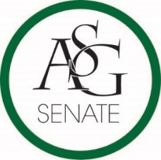
Senate Agenda
September 11th, 2018
Graduate Education Auditorium, 6:00 PM
- Call to Order
- Roll Call
- Approval of the Minutes
- Special Orders
  - Reports (5 minutes each)
    - Special Reports
    - Advisor, Mary Skinner
    - Graduate Assistants, Joshua Saraping and Sage McCoy
    - President, J.P. Gairhan
    - Vice-President, Abigail Walker
    - Treasurer, Isamar Garcia
    - Secretary, Luke Humphrey
    - Chief Justice, Julianna Tidwell
    - GSC Speaker, Arley Ward
    - Cabinet Reports
      - Chief of Staff, Carus Newman
    - FLF Coordinator, Will Clark
    - Chair of the Senate, Colman Betler
- Appointments, Nominations, and Elections
  - Fulbright Caucus Chair
  - Walton Caucus Chair
  - Bumpers Caucus Chair
  - Engineering Caucus Chair
  - Infrastructure Chair
  - Academics Chair
  - Internal Affairs Chair
  - Campus Life Chair
  - Allocations Chair
  - Parliamentarian
  - Sergeant at Arms
  - Legislative Clerk
  - Pro-Tempore Committee
  - Code and Constitution Ad-hoc Committee
- Public Comment (3 at 2 minutes each)
- Old Business
- New Business
- Announcements
- Adjournment

