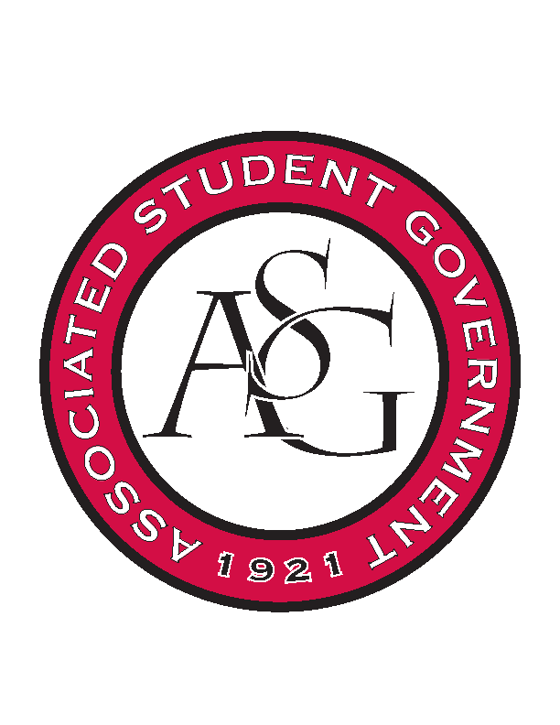
Associated Student Government
RSO Financial Affairs Meeting Minutes
January 19, 2017

- Call To Order
- Roll Call
  - Adam Jones
  - Isamar Garcia
  - Colton Smith
  - Jacob Stansell
  - Jalen Hemphill
  - Macarena Arce
  - Paige Ooton
  - Ramon Silvera
  - Drew Maney
- Approval of the Agenda
  - approved
- Approval of the Minutes
  - approved
- Appeal
- Audit Reports
- Old Business
  - Black Graduate Student Organization
      - Drop number of gallons of ice tea to 6 and water to 12
      - decided it was a non-ticket event
      - approved (9-0)
  - Bangladesh Student Organization
      - Flowers are part of cultural significance
      - order flowers from Sam’s Club
      - include money ($50) for ticketing in case it is required
      - approved (9-0)
- New Business
  - The Wildlife Society
      - looks good
      - approved (9-0)
  - Eta Sigma Delta
      - late!
      - Deny (9-0)
  - Phi Beta Sigma
      - Exactly on time
      - Approved (9-0)
  - Acts of Random Kindness
      - cut $17 from miscellaneous
      - $20 for administration fees added
      - Approved (9-0)
  - Iranian Students Organization
      - Why is the hot wire foam cutter necessary
      - cut pennies from the budget, not financially viable?
      - why are uplights necessary?
      - Ask Union if they already possess equipment for uplighting
      - All things from Hobby Lobby can be bought at Wal Mart
      - approved (9-0)
  - The German Club
      - approved (9-0)
  - The American Marketing Association
      - What is the actual due date for money?
      - approved(9-0)
- Announcements
  - Senate Vacancy
  - Colin is da bomb
- Adjournment
  - 5:41 PM

