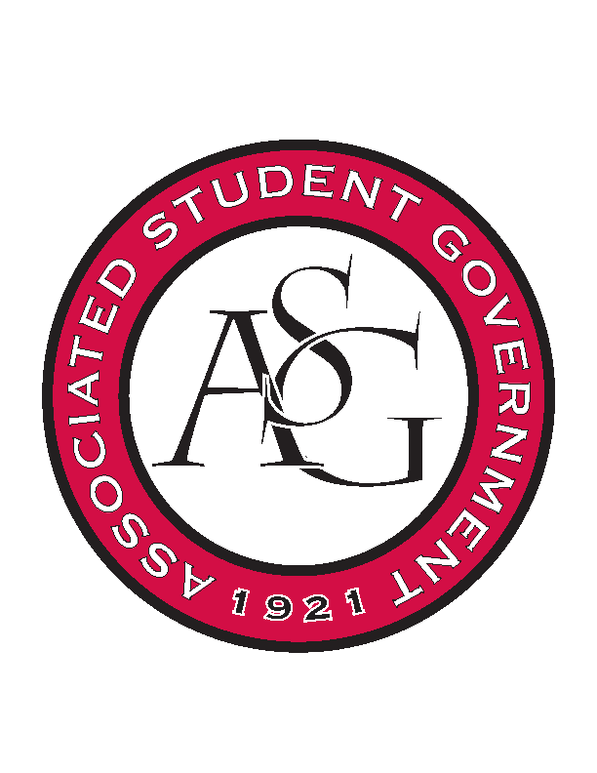
Associated Student Government

RSO Financial Affairs Meeting Minutes
January 26, 2017

- Call To Order
  - (5:00)
- Roll Call
  - Adam Jones
  - Isamar Garcia
  - Colton Smith
  - Jacob Stansell
  - Jalen Hemphill
  - Macarena Arce
  - Paige Ooton
  - Ramon Silvera
  - Drew Maney
      - Proxy: Dani Zapata
- Approval of the Agenda
  - (approved)
- Approval of the Minutes
  - (approved)
- Appeal
- Audit Reports
- Old Business
  - The Wildlife Society
      - Approved (9-0)
  - Phi Beta Sigma
      - Approved (9-0)
  - Acts of Random Kindness
      - Approved (9-0)
  - Iranian Students Organization
      - Cultural event
      - Items are cheaper, prepared list of comparisons between lowes wal mart and hobby lobby
      - Hot wire cutter removed
      - Uplights removed
      - Pennies removed
      - Need make up mirror back after event
      - Table cloths at wal- mart
      - Approved (9-0)
  - The German Club
      - Approved (9-0)
  - The American Marketing Association
      - Late, due date was February 6
- New Business
  - Fulbright Scholars
      - Clarify the date of the event
      - Moved food items into miscellaneous for clarity
      - Approved (9-0)
  - Student Nurses Association
      - Confirm event date and money due date
      - Approved (9-0)
  - Association of Ceramic Enthusiasts
      - Clarify price and let them know they will only get the money they asked for
      - Approved (9-0)
  - Printmaking Club
      - $1,250 funding limit for conference
      - more information
      - Approved (9-0)
  - Biological Engineering Student Organization
      - The link for the website was not working
      - We need proof
      - No fundraising allowed, break even only
      - Deny (9-0)
  - National Society of Black Engineers
      - Conference
      - Approved (9-0)
  - Geo- Institute Graduate Student Organization
      - Conference
      - Approved (9-0)
  - Block and Bridle
      - Late
      - Pay registration fees on site?
      - Budget is over $1,250 funding limit for conferences
      - Deny (9-0)
  - Contemporary Sculpture Society
      - Exclusive?
      - Too many nights for speaker?
      - Ulterior motives for the curator to come judge art?
      - Selling art?
      - Approved (5-4)
  - Student Alumni Association
      - Late
      - Deny (9-0)
  - National Association of Black Geoscientists
      - Incomplete application
      - No location
      - Itemized list of food?
      - Deny (9-0)
  - Biology Graduate Student Association
    - Event
      - No start or end time
      - No per diem
      - Avoided pre event by keeping budget under 999.99
      - Exclusive to your RSO
      - Deny (9-0)
    - Conference
      - Approved (9-0)
  - Russian- Eurasian Student Organization
      - Event time?
      - Approved (9-0)
- Announcements
  - Proxies please stay after for a quick intro to OFA!
  - RSO Involvement Fair
      - Feb 22nd 11-2 pm Connections Lounge
- Adjournment

