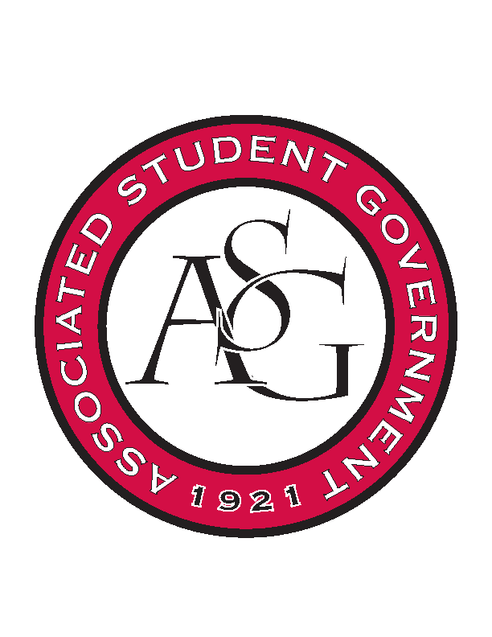
Associated Student Government

RSO Financial Affairs Meeting Agenda
October 13th, 2016

- Call To Order
- Roll Call
- Approval of the Minutes
- Audit Reports
- Old Business
  - Biology Graduate Student Organization
      - 5-0 Approved
  - Muslim Students Organization
      - 5-0 Approved
  - Panamanian Students Organization
      - 5-0 Approved
  - Pi Sigma Alpha
      - 5-0 Approved
  - Razorback Jugglers
      - 5-0 Approved
  - The German Club
      - 5-0 Approved
  - Undergraduate Mock Trial
      - 5-0 Approved
- New Business
  - Chi Alpha
      - 5-0 denied
      - Late
  - Business Law Society
      - 5-0 Denied
  - Fabula Bound
      - 5-0 Approved
  - Hmong Student Organization
      - 5-0 Approved
      - Ask about drink
  - Student Chapter of the American Choral Directors Association
      - 5-0 Approved
      - Cut to $1,000
  - Biology Club
      - Approved 5-0
      - Ask about end time
  - Association of Ceramic Enthusiast
      - Approved 5-0
  - African Students Association
      - Denied 4-1
      - Late
  - Andiamo a Roma
      - 5-0 Approved
  - Society of Women Engineers
      - 5-0 Approved
  - Lao American Organization
      - 5-0 Approved
      - Ask about educational value
  - International Student Organization
      - 5-0 Approved
      - Ask about catering company & sound equipment
- Announcements
  - Email about clean copy of Standing Rules coming soon
  - THANK YOU to those of you at the Chancellors Ball & All Call!
  - Haven training- Sexual Assault bystander education.
      - Look for email!
      - ASG will be completing before Oct. 31st!
- Adjournment

