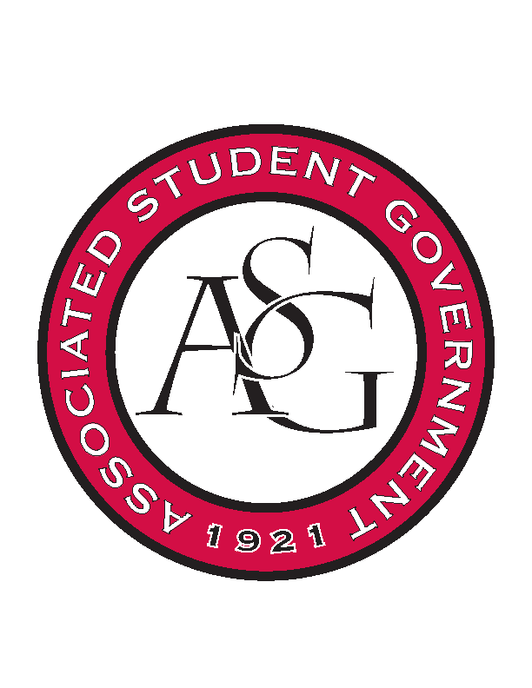
Associated Student Government

RSO Financial Affairs Meeting Agenda
October 20th, 2016

- Call To Order
  - (5:00)
- Roll Call
  - Adam Jones
  - Collins Kiogothi
  - Colton Smith
  - Jacob Stansell
  - Jalen Hemphill
  - Macarena Arce
  - Paige Ooton
  - Ramon Silvera
  - Stephanie Galen
      - Proxy: Andrew
- Approval of the Minutes
- Audit Reports
- Old Business
  - Fabula Bound
      - Approved (9-0)
  - Hmong Students Association
      - Approved (9-0)
  - Student Chapter of the American Choral Directors Association
      - Changed from 8 to 5 attending to keep funding under $1,000
      - Approved (9-0)
  - Biology Club
      - Approved (9-0)
  - Association of Ceramic Enthusiast
      - Art department is covering day three and a portion of honorarium
      - Approved (9-0)
  - Andiamo a Roma
      - Recruitment
      - Approved (9-0)
  - Society of Women Engineers
      - Approved (9-0)
  - Lao American Organization
      - Educational value?
      - Approved (9-0)
  - International Student Organization
      - No express lunch boxes
      - Approved (9-0)
- New Business
  - Electrochemical Society, UofA Student Chapter
      - Late
      - Deny (9-0)
  - You Only Live Optimistically
      - Lots of caterers? Clarify
      - Ask about a co-sponsor
      - Time?
      - Exceeded capacity last year?
      - Approved (9-0)
  - Russian-Eurasian Student Organization
      - 7.5 hours lecture?
      - Artisan lunch box are exclusive?
      - $229.80 for cookies and punch or nothing
      - 2 hotel nights?
      - Approved (9-0)
  - Muslimahs of the University of Arkansas
      - More details
      - Caterer?
      - Speaker? Bio?
      - Water in miscellaneous?
      - Recruitment?
      - Deny (8-1)
  - Contemporary Sculpture Society
      - Speaker, 2 different ones?
      - No food so no tickets?
      - No pre event consultation?
      - Deny (9-0)
  - Iranian Students Association
      - Late with thanksgiving
      - Deny (9-0)
  - Brazilian Students Organization
      - Disposables?
      - Food with speaker from Memphis?
      - Food somewhere else?
      - Food safety, sanitation, preservation?
      - Approved (9-0)
- Announcements
  - Standing Rules
  - THANK YOU to those of you at the Chancellors Ball & All Call!
  - Haven training- Sexual Assault bystander education.
      - ASG will be completing before Oct. 31st!
- Adjournment
  - (5:39)

