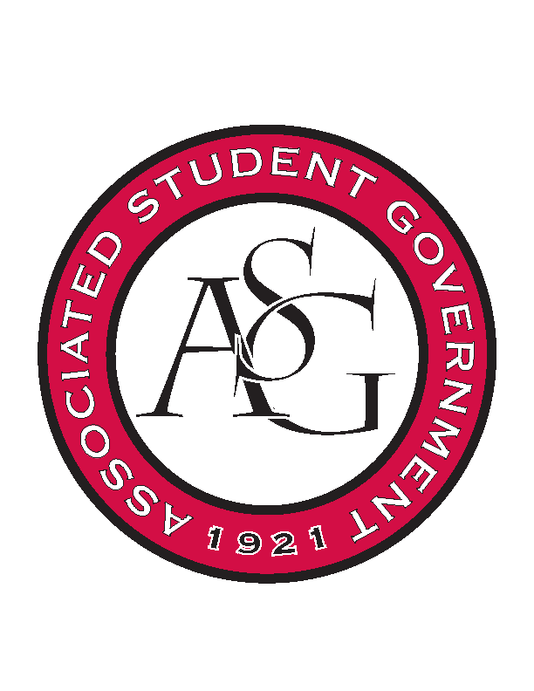
Associated Student Government

RSO Financial Affairs Meeting Minutes
October 6th, 2016

- Call To Order
  - (5:03)
- Roll Call
  - Adam Jones
  - Collins Kiogothi
  - Colton Smith
  - Jacob Stansell
      - Proxy: Isamar G
  - Jalen Hemphill
  - Macarena Arce
  - Paige Ooton
      - Proxy: Andrew
  - Ramon Silvera
  - Stephanie Galen
- Approval of the Minutes
- Audit Reports
- Old Business
  - Bangladesh Student Organization
      - Approved (9-0)
  - Biomedical Engineering Society
      - Approved (9-0)
  - Black Law Students Association
      - Approved (9-0)
  - Board of Advocates
      - Approved (9-0)
  - National Lawyers Guild UofA Chapter
      - Approved (9-0)
  - Plant Pathology Graduate Student Organization
      - Approved (9-0)
  - UARK Art Educations Association
      - Approved (9-0)
  - Vietnamese Student Organization
      - Cutting Windex Approved (8-1)
      - Approved (9-0)
- New Business
  - Biology Graduate Student Organization
      - Approved (9-0)
  - Chi Epsilon
      - Inclusive to RSO
      - Party
      - Expensive pizza
      - Deny (9-0)
  - Muslim Students Organization
      - More detail on whats happening at the event
      - Staying two nights?
      - Approved (9-0)
  - Panamanian Students Organization
      - Approved (9-0)
  - Pi Sigma Alpha
      - Inclusive?
      - Plan for promotion?
      - Approved (9-0)
  - Razorback Jugglers
      - Approved (9-0)
  - Sport Professionals Association
      - Late
      - Deny (9-0)
  - The German Club
      - Promotion? Email professors?
      - Packaged bratwurst?
      - Grills?
      - Craft lanterns or store bought?
      - Approved (9-0)
  - Undergraduate Mock Trial
      - Approved (9-0)
      - Two events approved
- Standing Rules
- Announcements
- Adjournment

