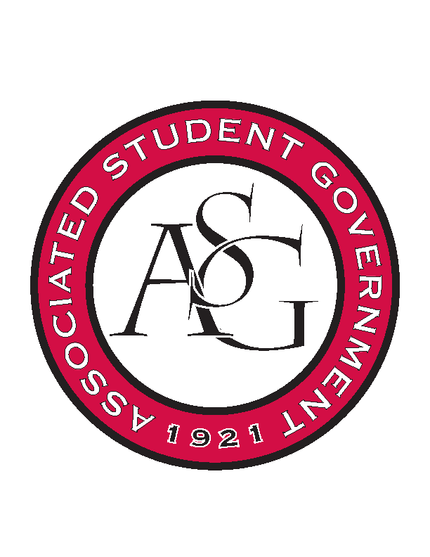
Associated Student Government

RSO Financial Affairs Meeting Minutes
November 10th, 2016

- Call To Order
  - (4:59)
- Roll Call
  - Adam Jones
  - Collins Kiogothi
  - Colton Smith
  - Jacob Stansell
  - Jalen Hemphill
  - Macarena Arce
      - Proxy: Andrew Estes
  - Paige Ooton
  - Ramon Silvera
  - Stephanie Galen
        - Proxies present: Isamar
- Approval of the Minutes
  - Approved
- Appeal
  - Printmaking Club
      - Alexis & Lauren
      - Art department funds Thursday night art lectures
      - Practicality- 9 hour drive from LSU
      - One-hour lecture followed by 30 minutes of Q & A followed by personal conversation with artist
      - Two full days for class visits and campus touring
      - Tour the community and crystal bridges
      - Approved an extra night (8-1)
- Audit Reports
- Old Business
  - None
- New Business
  - Alpha Kappa Psi
      - $99 for early bird but late if so
      - $150 for regular price and on time
      - Approved (9-0)
- Announcements
  - Standing Rules updated
  - Audits- 3 weeks left. You all need 2!!
  - ASG All-Call Nov 16th!
- Adjournment
  - (5:24)

