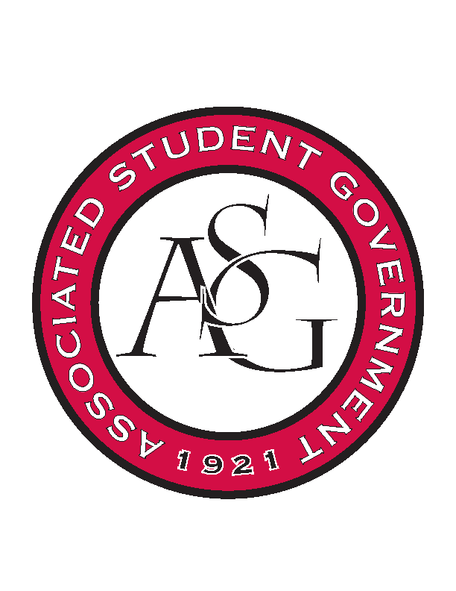
Associated Student Government

RSO Financial Affairs Meeting Minutes
November 3rd, 2016

- Call To Order (5:00)
- Roll Call
  - Adam Jones
  - Collins Kiogothi
      - Proxy: Andrew Estes
  - Colton Smith
  - Jacob Stansell
  - Jalen Hemphill
  - Macarena Arce
  - Paige Ooton
      - Proxy: Isamar
  - Ramon Silvera
  - Stephanie Galen
- Approval of the Minutes
  - (Approved)
- Audit Reports
  - Isamar- Friends of India
  - Jalen- SpaceHOGS
- Old Business
  - Printmaking Club
      - Adjusted budget for one hotel night
      - Per diem adjusted for one night
      - Approved (9-0)
  - Arkansas Chemical Engineering Graduate Student Organization
      - Approved (9-0)
- New Business
  - Engineering World Health
      - Late
      - Deny (9-0)
  - Chi Alpha
      - Late
      - Deny (9-0)
  - ASCEND
      - Late
      - Deny (9-0)
- Announcements
  - Standing Rules passed senate!
      - GSC 1st reading Monday
  - Haven training- Sexual Assault bystander education.
  - Audits- 4 weeks left. You all need 2!!
  - ASG All-Call Nov 16th!
- Adjournment
  - (5:17)

