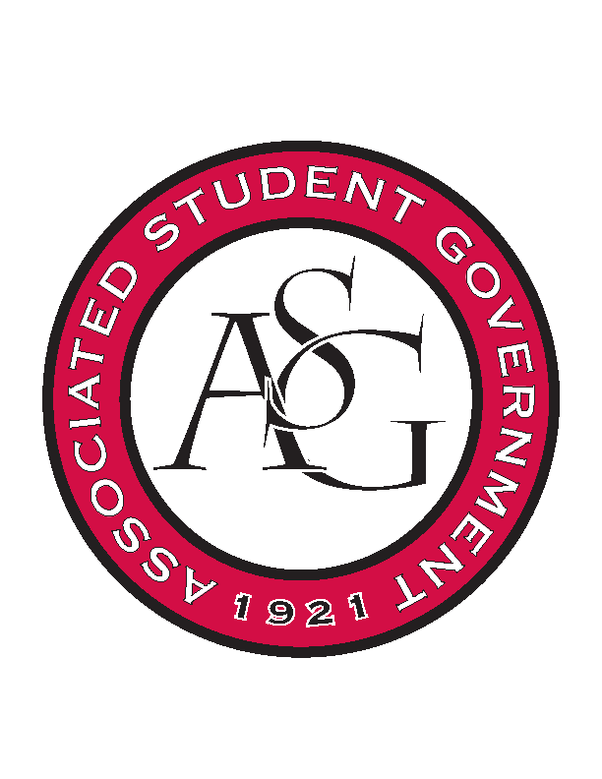
Associated Student Government

RSO Financial Affairs Meeting Minutes
December 1st, 2016

- Call To Order
  - (5:00)
- Roll Call
  - Adam Jones
  - Collins Kiogothi
  - Colton Smith
  - Jacob Stansell
  - Jalen Hemphill
  - Macarena Arce
  - Paige Ooton
  - Ramon Silvera
  - Stephanie Galen
- Approval of the Agenda
  - (approved)
- Approval of the Minutes
  - (approved)
- Appeal
- Audit Reports
  - Adam- positive teas and Rome
  - Ramon- positive teas
  - Jalen-
  - Macarena- PositiviTea & Laos & Brazilian
- Old Business
  - Iranian Students Association
      - Approved (9-0)
  - Chinese Students and Scholars Association
      - Approved (9-0)
- New Business
  - Profound Pioneers Entertainment Group
      - Late
      - Deny (9-0)
  - Agriculture Communicators of Tomorrow
      - Late
      - Deny (9-0)
  - Sports Analytics
      - $32.64 extra, add to budget?
      - Approved (9-0)
  - Alpha Epsilon Delta
      - Exclusive
      - Awards ceremony with a speaker
      - No initiation
      - Professional for everyone
      - Students being recognized for what
      - Students only
      - Speaker vs initiation time
      - Approved (6-3)
  - Association of Ceramic Enthusiasts
      - Late
      - Over budget
      - Register in march
      - Can only fund up to $1000
      - Deny (9-0)
- Announcements
  - Standing Rules- effective January!
  - Holiday Party!!
      - Dec 6 @ 7pm. US PIZZA
      - Tacky sweaters
- Adjournment

