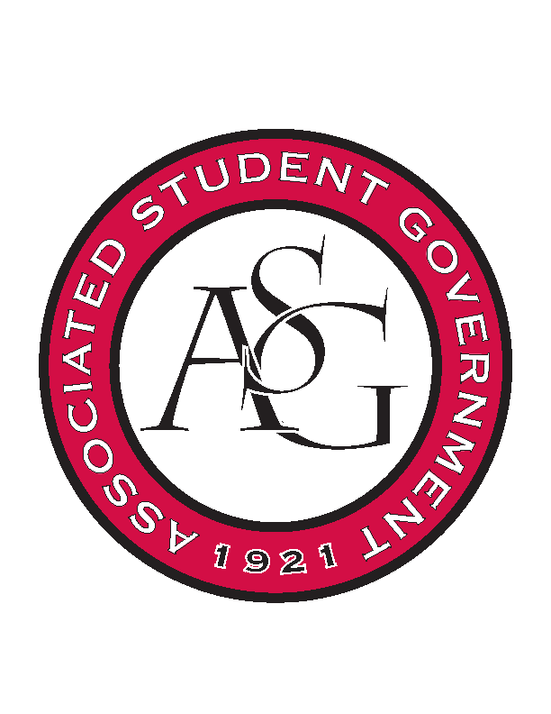
Associated Student Government

RSO Financial Affairs Meeting Agenda
December 8th, 2016

- Call To Order
  - (4:59)
- Roll Call
  - Adam Jones
  - Collins Kiogothi
  - Colton Smith
  - Jacob Stansell
  - Jalen Hemphill
  - Macarena Arce
  - Paige Ooton
  - Ramon Silvera
  - Stephanie Galen
- Approval of the Agenda
  - (approved)
- Approval of the Minutes
  - (approved)
- Appeal
- Audit Reports
- Old Business
  - Sports Analytics
      - Increased funding for a fee
      - Approved (9-0)
  - Alpha Epsilon Delta
      - Approved (5-4)
- New Business
  - Information Graduate Students Organization
      - Price per head
      - 14 people in RSO and attending
      - exclusivity
      - Deny (9-0)
  - Black Graduate Student Organization
      - Price per head over
      - Make the event seem more open
      - “for the black population” line
      - Approved (9-0)
  - Bangladesh Student Organization
      - Cut flowers and Walmart gift card
      - Flowers cheaper
      - Educational? How are they going to learn things
      - Approved (9-0)
- Announcements
- Adjournment
(5:30)

