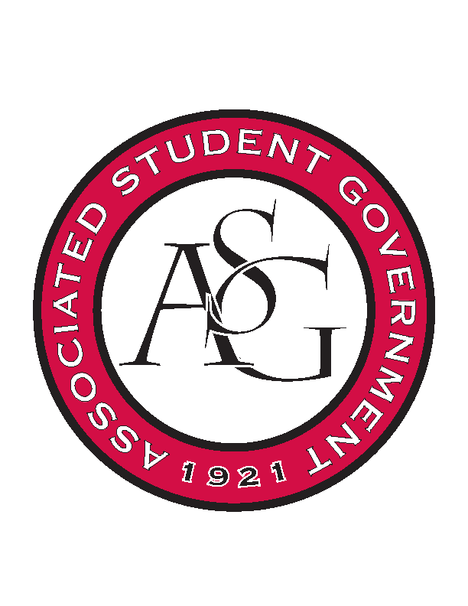
Associated Student Government

RSO Financial Affairs Meeting Agenda
February 9, 2017

- Call To Order

- Roll Call
  - Adam Jones
  - Isamar Garcia
      - Proxy: Dani Zapata
  - Colton Smith
      - Proxy: Nathan Smith, Starting at 5:49/ Muslim Students Association
  - Jacob Stansell
  - Jalen Hemphill
  - Macarena Arce
  - Paige Ooton
  - Ramon Silvera
  - Drew Maney
      - Left at 5:59/ Society of Art Historians
- Approval of the Agenda
  - (approved)
- Approval of the Minutes
  - (approved)
- Appeal
  - Biological Engineering Student Club- tabled last week
      - Hosting regional rally this year for south eastern chapter
      - $40/ person includes shirts, food, water bottles, t shirts
      - 150 students estimated
      - covers chart wells and union fee cost
      - Moved to second reading by Macarena Arce
        - Seconded by Paige Ooton
        - Approved (9-0)
      - Approved (9-0)
  - Graduate Students in English
      - Supplies?
      - Used the old budget initially, when transferring over to new budget a few lines were not filled in
      - Panels in different rooms
      - 70 are expected to come due to the publicity from a particular professor and a broader topic for interest
      - name badges are cheaper than on budget so we want to cut down expenses
      - still incomplete but we got more information in person now
      - old form version
      - Deny (9-0)
  - Electrochemical Society
      - Meeting with a RED talk?
      - Eureka Pizza added to form
      - Drinks from Wal- Mart
      - Clarification of speaker
      - Change time to 5:00 – 6:30 PM
      - Approved (7-2)
- Audit Reports
- Old Business
  - American Marketing Association
      - Approved (9-0)
  - Muslim Students Association
      - Approved (9-0)
  - SPACE HOGS
      - Approved (9-0)
  - Block and Bridle
      - Cut down to $1,250 for conference
      - Approved (9-0)
  - Association of Latino Professionals for America
      - Networking event
      - Approved (9-0)
  - Chi Epsilon
      - Conference
      - Approved (9-0)
  - African Students Organization
      - Changed tableware cost from $300 to $150 in budget
      - All food must be prepared on site at the Fayetteville Town Square. Food may not be prepared elsewhere and brought to the Town Center
      - Approved (9-0)
  - Society of Art Historians
      - Approved (9-0)
- New Business
  - Give Love to Our Women
      - 2 liter price changed and moved to miscellaneous
      - Per Diem was removed and added to honorarium if they would like us to do that for their speaker.
      - Ask if they want to change travel costs to meet standing rules
      - Approved (8-0)
  - Hmong Student Organization
      - Macarena motion to adjust the $1,400 to our $1,250 maximum
        - Seconded by Jalen an approved
      - Look at the budget and fix the bottom value
      - Approved (8-0)
  - Institute of Industrial and Systems Engineers 1
      - Food for non-students
      - Recruitment event
      - Ratio of students to no students is off, staff maybe?
      - Administrative funds can only be attained once a year
      - Educational value?
      - Deny (8-0)
  - Institute of Industrial and Systems Engineers 2
      - Event is after dead day/ during finals week
      - Deny (8-0)
  - Russian-Eurasian Student Organization- Masha Gessen (resubmitted)
      - Reiterate 2 days per diem
      - Approved (8-0)
- Announcements
  - RSO Involvement Fair
      - Feb 22nd 11-2 pm Connections Lounge
  - OSA Day
      - Feb 15th 11-2pm Connections Lounge
  - Office Hours
  - Audit reports
      - Chinese student new year
        - Packed
        - Great event
        - Macarena and Paige attended
- Adjournment
    - Send Colin notes for whatever you need done for events

