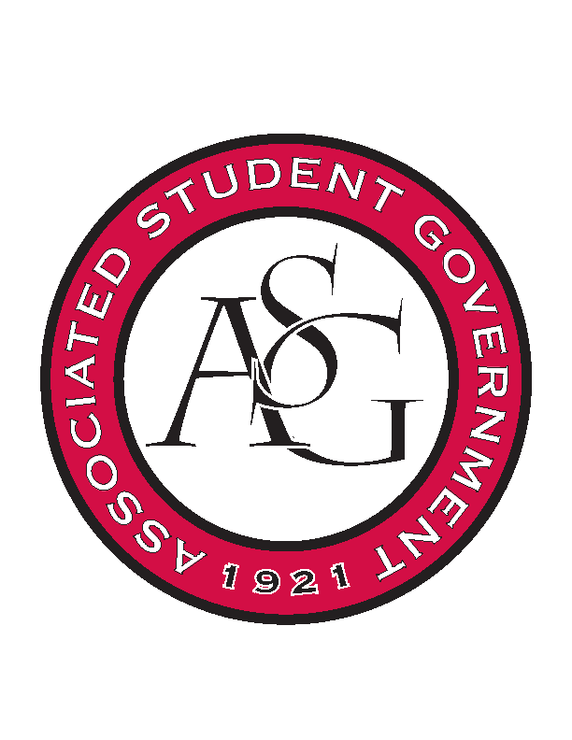
Associated Student Government

RSO Financial Affairs Meeting Minutes
March 16th, 2017

- Call To Order
  - 5:03
- Roll Call
  - Adam Jones
  - Jacob Stansell
  - Macarena Arce
  - Jalen Hemphill
  - Isamar
  - Paige
      - Proxy: Grant
  - Colton
      - Proxy: Dani
  - Drew Maney
      - Absent
  - Ramon
      - Absent
- Approval of the Minutes
- Audit Reports
  - Macarena: Iranian Immersion
- Old Business
  - Brazilian Student Organization
      - Approved: 7-0
  - Korean Student Organization
      - Suggest a bigger area
      - Approved: 7-0
  - Agro-Panama International
      - International flight?
      - Are they a US citizen?
      - Approved: 7-0
  - Fabula Bound
      - Approved 6-0-1 (Jacob abstained)
  - Black Law Student Association
      - Approved 7-0
  - Eta Sigma Phi
      - Approved 7-0
- New Business
  - Badminton Club
      - No education value
      - Denied 7-0
  - Ascend
      - Approved 7-0
  - YOLO
      - Cups? Soap?
      - Approved 7-0
  - International Student Organization
      - African Performers to honorarium
      - Rental fee for audio mixer?
      - More details on agenda for the night
      - Approved 7-0
  - Razorback Jugglers
      - Late
      - Denied 7-0
  - ALPFA- Association of Latino Professional Students For America
      - When can you register?
      - Approved 7-0
  - Arkansas Chemical Engineering Graduate Students
      - What’s the purpose? Is the poster presentation all that is going on?
      - Asked for admin funds, but wasn’t in the budget proposal. Do they want it?
      - Approved 7-0
  - Medieval and Renaissance Graduate Colloquy
      - Approved 7-0
- Standing Rules
  - Changed funding deadline in line 53-54.
  - Approved 7-0
- Announcements
- Adjournment

