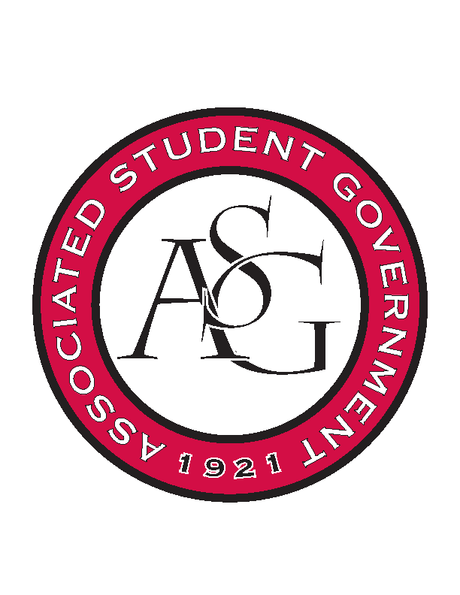
Associated Student Government

RSO Financial Affairs Meeting Agenda
March 9th, 2017

- Call To Order
  - (5:04 PM)
- Roll Call
  - Adam Jones
      - Absent
  - Isamar Garcia
  - Colton Smith
  - Jacob Stansell
  - Jalen Hemphill
      - Proxy: Dani Zapata
  - Macarena Arce
  - Paige Ooton
  - Ramon Silvera
  - Drew Maney
      - Proxy: Nathan
- Approval of the Minutes
- Audit Reports
- Old Business
  - Psychology Club
      - Approved (8-0)
  - Nepali Association of Northwest Arkansas
      - Cut bowls, cutlery, etc. down to $100
      - Approved (8-0)
  - Caribbean Students Organization
      - Cut DJ from budget because it lacks educational value and is too expensive
      - Approved (8-0)
  - Friends of India
      - Approved (8-0)
  - Filipino Students Organization
      - Approved (8-0)
  - Electrochemical Society, UofA Student Chapter
      - Finalize travel before we can fund
      - No buffer nights- hotel night, per diem and honorarium cut for one night.
      - Approved (8-0)
  - Isely-Baerg Entomology Club
      - Approved (8-0)
  - Solar Splash Boat Team
      - Approved (8-0)
  - Ascend Univeristy of Arkansas Student Chapter
      - Approved (8-0)
  - Il Circolo Italiano
      - Somebody should audit
      - Approved (8-0)
- New Business
  - Brazilian Student Organization
      - Description?
      - Line 17? Incomplete?
      - Educational value elaboration?
      - Holcombe might be too small for 130 people? Other locations or smaller number of people?
      - Approved (8-0)
  - Korean Student Organization
      - Travel to Korea
      - What is happening at the event?
      - Approved (8-0)
  - Agro-Panama International
      - 2 nights?
      - Partnering with UP but still 290 is a lot of people?
      - Ensure that this many people will come to the event
      - add required advertisements
      - Approved (8-0)
  - Theta Tau
      - Late
      - Incomplete budget- no conference website
      - Deny (8-0)
  - Fabula Bound
      - Educational value?
      - End time? For catering?
      - Networking event?
      - Can other people submit to the event?
      - Fiddler free at Mullins?
      - Approved (8-0)
  - Black Law Student Association
      - Needs more information about speaker’s speech
      - Need more information about event itinerary
      - Approved (8-0)
  - Eta Sigma Phi

      - Approved (8-0)
- Standing Rules
- Announcements
- Adjournment

