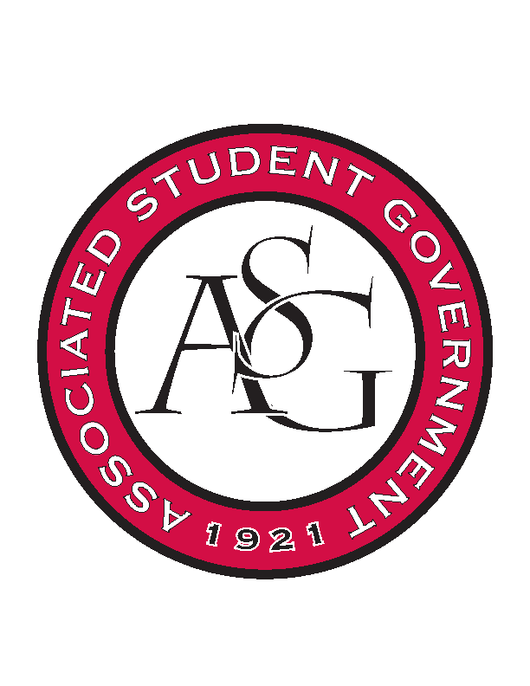
Associated Student Government

RSO Financial Affairs Meeting Minutes
April 20th, 2017

- Call To Order
  - (5:01)
- Roll Call
  - Adam Jones
  - Jacob Stansell
  - Macarena Arce
      - Proxy: Dani
  - Jalen Hemphill
  - Isamar Garcia
  - Paige Ooton
  - Colton Smith
  - Drew Maney
  - Ramon Silvera
      - Proxy: Grant
- Approval of the Minutes
- Audit Reports
- Old Business
  - Ascend
      - Approved (9-0)
  - Contemporary Sculpture Society
      - Cut down hotel and per diem down to one night
      - Approved (9-0)
  - Public Relations Society of America
      - Approved (9-0)
  - Biology Club
      - Napkins and plates from Walmart
      - Approved (9-0)
- New Business
  - Student Alumni Association- conference
      - Late
      - Deny (8-0-1)
  - Student Alumni Association- event
      - Late
      - No pre- event consultation
      - Deny (8-0-1)
  - Student Mobilization
      - Handouts, drinks, candy? Elaboration please
      - Recruitment?
      - No raffles!
      - Approved (9-0)
  - Alpha Epsilon Delta
      - Need more information
      - What is happening?
      - Is this a special event and why?
      - We need an email!
      - Elaborate on the speaker
      - Clarify on the catering company
      - Approved (9-0)
  - Black Graduate Student Association
      - Need to market to undergraduates
      - Networking event
      - Ice cream/ novelty? Clarify
      - Cannot buy tent, $300 rental?
      - Can they use ASG tent?
      - Potentially moving condiments to food rather than miscellaneous
      - Where are they getting the tent? Vendor?
      - Approved (9-0)
  - Engineering Safety
      - Catering company?
      - Approved (9-0)
- Announcements
- Adjournment
    - (5:26)

