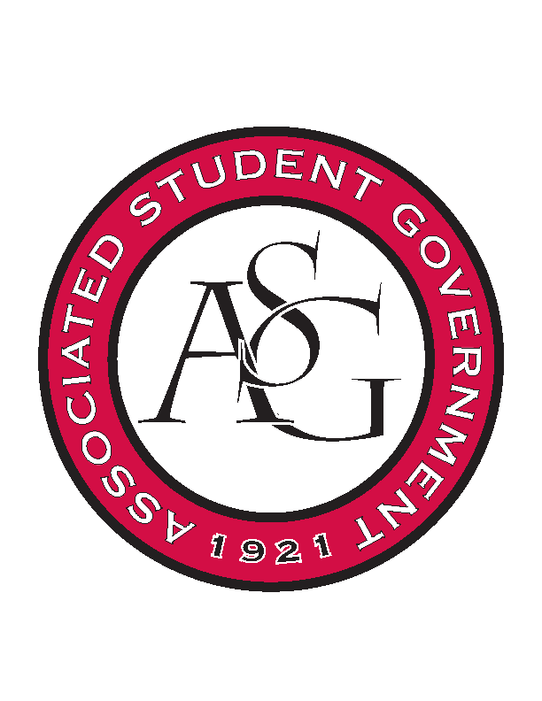
Associated Student Government

RSO Financial Affairs Meeting Minutes
April 27th, 2017

- Call To Order
  - (5:01)
- Roll Call
  - Adam Jones
  - Jacob Stansell
  - Macarena Arce
  - Jalen Hemphill
  - Isamar Garcia
  - Paige Ooton
  - Colton Smith
  - Drew Maney
      - Proxy: Dani Zapata
  - Ramon Silvera
- Approval of the Minutes
- Appeal
  - Contemporary Sculpture Society
      - Tell art department to pay
      - Vote to not change budget
      - Approved (9-0)
- Audit Reports
- Old Business
  - Student Mobilization
      - Recruitment?
      - Regularly scheduled meeting?
      - Budget cut down to $100 +tax
      - Approved (9-0)
  - Alpha Epsilon Delta
      - Approved (9-0)
  - Black Graduate Student Association
      - Approved (9-0)
  - Engineering Safety
      - Sam’s club
      - Approved (9-0)
- New Business
  - Rooted
      - Cut down to $1,250
      - Details on itinerary of conference?
      - Pricing for sign up?
      - Location?
      - Approved (9-0)
  - Razorback Athletic Trainers Association
      - One day late
      - Deny (9-0)
  - Chinese Students & Scholars Association
      - Tickets
      - Approved (9-0)
  - Full Stomachs Clean Feet
      - More information on the event
      - Approved (9-0)
- Announcements
- Adjournment
    - (5:33)

