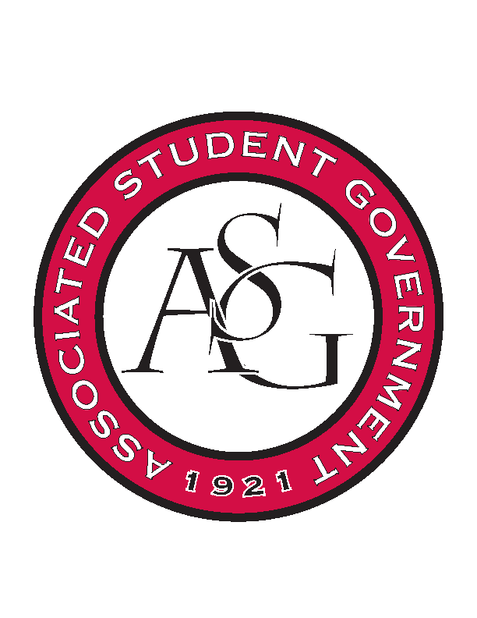
Associated Student Government

RSO Financial Affairs Meeting Agenda
April 6th, 2017

- Call To Order
  - (5:00)
- Roll Call
  - Adam Jones
  - Jacob Stansell
  - Macarena Arce
  - Jalen Hemphill
      - Proxy: Nathan Hale
  - Isamar Garcia
  - Paige Ooton
  - Colton Smith
      - Proxy: Andrew Estes
  - Drew Maney
      - Proxy: Dani Zapata
  - Ramon Silvera
- Approval of the Minutes
- Audit Reports
  - Paige, Dani, Colin
- Old Business
  - Simple Truth
      - We do not have the due dates.
      - Deny (9-0)
  - PRIDE
      - Approved (9-0)
  - Undergraduate Mock Trial
      - Approved (9-0)
  - Muslimas of University of Arkansas
      - Approved (9-0)
  - Eta Sigma Delta
      - Approved for $650 (9-0)
  - Advertising Club
      - Approved (9-0)
- New Business
  - InterVarsity
      - $280 per person
      - $260 per person if early bird
      - incomplete budget because we have no contact information
      - Deny (9-0)
  - The Higher Education Organization
      - Late
      - Deny (9-0)
  - Hermandad de Sigma Iota
      - Late
      - Deny (9-0)
  - ALPFA
      - Rescind denial from 3/30 (9-0)
        - Motion for Adam Jones
        - Seconded by Paige Ooton
          - Moved to second reading by Paige Ooton
          - Seconded by Ramon Silvera
          - Approved (9-0)
- Announcements
- Adjournment
  - (5:30)

