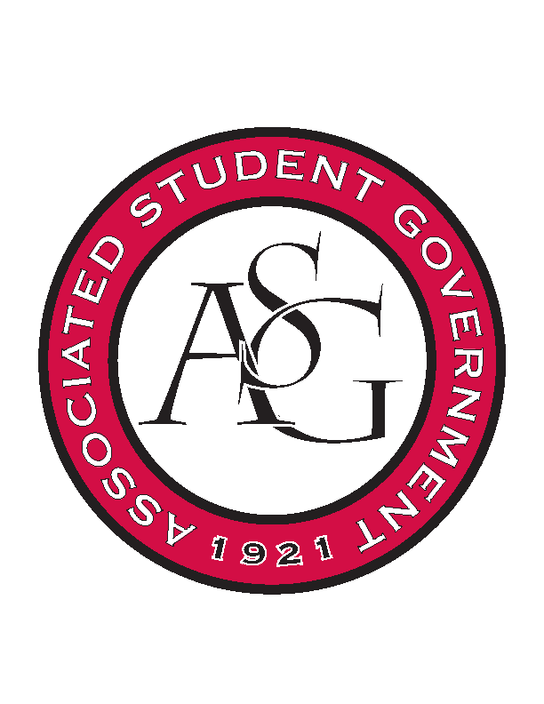
Associated Student Government

RSO Financial Affairs Meeting Agenda
May 4th, 2017

- Call To Order
  - (5:00)
- Roll Call
  - Adam Jones
  - Jacob Stansell
      - Proxy: Nathan
  - Macarena Arce
  - Jalen Hemphill
  - Isamar Garcia
  - Paige Ooton
      - Absent
  - Colton Smith
  - Drew Maney
  - Ramon Silvera
      - Absent
- Approval of the Minutes
- Appeal
  - Razorback Athletic Trainers Association
      - Event moved back two days- 9/13/17
      - Approved (7-0)
- Audit Reports
- Old Business
  - Rooted
      - Please appeal and come back first week in the fall!
      - Not enough information
      - No legitimate website
      - No legitimate due date
      - Deny (7-0)
  - Chinese Students & Scholars Association
      - Approved (7-0)
  - Full Stomachs Clean Feet
      - Moved bottled water to misc.
      - Approved (7-0)
- New Business
  - Student Alumni Association
      - Late
      - Deny (7-0)
- Announcements
- Adjournment
  - (5:28)

