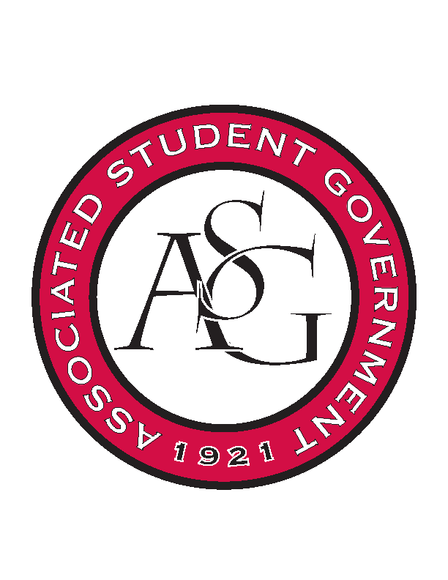
Associated Student Government

RSO Financial Affairs Meeting Agenda
September 1, 2016

- Call To Order
  - ( 5:08 )
- Roll Call
  - Adam Jones
  - Collins Kiogothi
  - Colton Smith
  - Jacob Stansell
  - Jalen Hemphill
  - Macarena Arce
  - Paige Ooton
  - Ramon Silvera
  - Stephanie Galen
- Approval of the Minutes (none)
- Audit Reports (none)
- Old Business
  - None
- New Business
  - UA Photographic Society
      - Art department contribution?
      - Approved 9-0
  - Theta Tau
      - Late
      - Website may not be credible, conference
      - Deny 9-0
  - Caribbean Students Association
      - Catering total corrected
      - Decorations for costumes or room?
      - Location? AU?
      - Approved 9-0 (second version)
  - Society of Women Engineers
      - Clarify collegiate SWE members
      - Signed up before 9/25 for $90
      - Approved 9-0
  - Razorback Athletic Trainers Association
      - Admin fee?
      - Eureka pizza at $5.99 and $3.00 delivery fee added
      - Approved 9-0
  - Lao American Organization
      - Incomplete, mission left blank, checklist
      - Deny 9-0
  - Sports and Entertainment Law Society
      - Expand on bio?
      - Ask for contact information for speaker
      - Co-sponsor contribution?
      - Approved 9-0
  - American Society of Interior Designers
      - Not an RSO
      - Speaker for two nights?
      - No vote
  - Students for Gender Equality
      - Not enough time for pre event consultation
      - Educational calling cards and buttons?
      - New banner?
      - Eureka pizza
      - Cups
      - Needs to be ticketed
      - Two nights in a hotel?
      - Chartwells caterer
      - Room reservation fee
      - Deny 9-0
- Other
  - Scheduling audits
      - Asterisk for events that NEED to be audited
      - Google sheets/ doc for volunteering
  - Standing rules- sustainability
      - No syrofoam, encourage plastic for recycling, cut PMC
  - Standing rules- edits
  - All Board picture
- Announcements
- Adjournment ( 5:56 )

