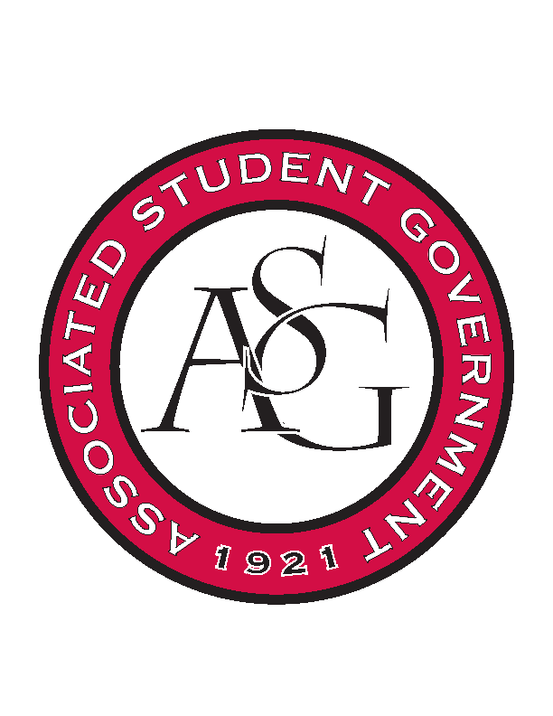
Associated Student Government

RSO Financial Affairs Meeting Agenda
September 15, 2016

- Call To Order
  - (4:59)
- Roll Call
  - Adam Jones
  - Collins Kiogothi
  - Colton Smith
  - Jacob Stansell
  - Jalen Hemphill
      - Proxy: Isamar Garcia
  - Macarena Arce
  - Paige Ooton
  - Ramon Silvera
  - Stephanie Galen
- Approval of the Minutes (approved)
- Audit Reports
- Old Business
  - American Society of Interior Designers
      - Approved (9-0)
  - Electrochemical Society, UofA Student Chapter
      - Approved (9-0)
  - Environmental Law Society
      - Approved (9-0)
  - Geo-Institute Graduate Student Organization
      - Approved for $111.75 (9-0)
  - Lao American Organization
      - Approved (9-0)
- New Business
  - Association of Latino Professionals for America
      - Approved (8-0-1)
  - Business Law Society
      - Open up advertising
      - Approved (9-0)
  - Crop, Soil, and Environmental Sciences Undergraduate Club
      - Pay earlier deadline
      - Approved (9-0)
  - Eta Sigma Delta
      - Late, resubmit for $75/ person
      - Deny (9-0)
  - Friends of India
      - What will be happening at the event?
      - Details for the programs
      - Speaker? UA students speaking?
      - Approved (9-0)
  - Fulbright Scholars
      - Speaker agreement?
      - Approved (9-0)
  - Hindu Students Association
      - Moved DJ to Honorarium
      - Approved (9-0)
  - Society of Hispanic Professional Engineers
      - Is lodging included in registration fee for conference?
      - $285?
      - Non lodging plans?
      - Approved (9-0)
  - SPACE Hogs
      - Event time? 7:00 PM
      - Add chartwells as caterer
      - Approved (9-0)
- Other
- Announcements
  - Standing Rules focus group meeting
      - 09.21.16
- Adjournment
  - (5:40)

