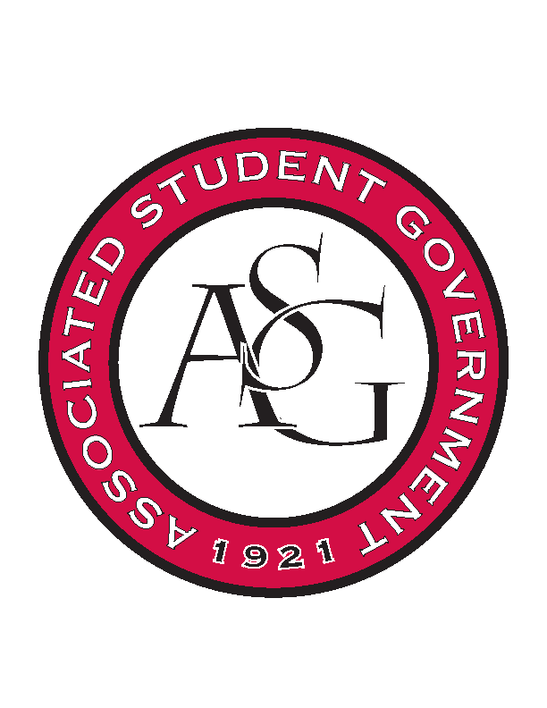
Associated Student Government

RSO Financial Affairs Meeting Agenda
September 22, 2016

- Call To Order
  - (time meeting)
- Roll Call
  - Adam Jones
  - Collins Kiogothi
      - Proxy: Isamar Garcia
  - Colton Smith
  - Jacob Stansell
  - Jalen Hemphill
  - Macarena Arce
      - Proxy: Drew Maney
  - Paige Ooton
      - Proxy: Andrew Estes
  - Ramon Silvera
      - Proxy: Pierce Philips
  - Stephanie Galen
- Approval of the Agenda
  - (approved)
- Approval of the Minutes
  - (approved)
- Audit Reports
  - (none)
- Old Business
  - Association of Latino Professionals for America
      - Approved (9-0)
  - Business Law Society
      - Approved (9-0)
      - Gratuity?
  - Crop, Soil, and Environmental Sciences Undergraduate Club
      - Approved (9-0)
  - Friends of India
      - Approved (9-0)
  - Fulbright Scholars
      - Approved (9-0)
  - Hindu Students Association
      - Approved (9-0)
  - Society of Hispanic Professional Engineers
      - Approved (9-0)
  - SPACE Hogs
      - Approved (9-0)
- New Business
  - Eta Sigma Delta
      - Standing rules- move checklist from RSO Funding to conference tab or above the event portion
      - Due date for fees
      - Sign budget
      - Approved (9-0)
  - History Organization of Graduate Students
      - Cut from 40 to 30 people
      - Gallons/ caterers in standing rules
      - Approved (9-0)
  - Il Circolo Italiano
      - Approved (9-0)
  - Japanese Students Association
      - Recruitment? General meeting?
      - Educational value?
      - Cut then re-apply based on recruitment event or cut them down to $111.75
      - Deny (5-4)
  - National Lawyers Guild, UofA Chapter
      - Incomplete- honorarium
      - 200 attendees in Waterman?
      - Tickets for crowd control
      - Deny (9-0)
- Other
  - Standing Rules
  - Audit Reports
- Announcements
- Adjournment
  - (5:37)

