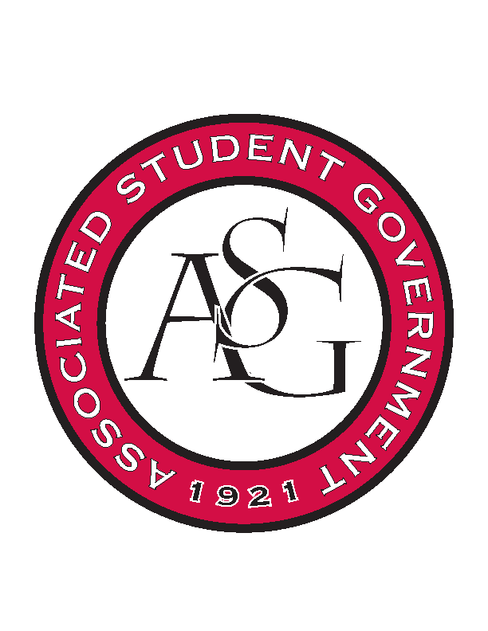
Associated Student Government

RSO Financial Affairs Meeting Agenda
March 2, 2017

- Call To Order
  - (4:59 PM)
- Roll Call
  - Adam Jones
  - Isamar Garcia
  - Colton Smith
  - Jacob Stansell
  - Jalen Hemphill
  - Macarena Arce
      - Proxy: Grant
  - Paige Ooton
      - Proxy: Nathan
  - Ramon Silvera
  - Drew Maney
      - Proxy: Dani Zapata
- Approval of the Agenda
  - (Approved)
- Approval of the Minutes
  - (Approved)
- Appeal
- Audit Reports
- Old Business
  - Tau Beta Pi
      - Approved (9-0)
  - Panamanian Students Organization
      - Approved (9-0)
  - Al-Islam Students Association
      - Approved (9-0)
  - Hindu Students Association
      - Approved (9-0)
  - Kappa Kappa Psi
      - Approved (9-0)
- New Business
  - Psychology Club
      - Approved (9-0)
  - Nepali Association of Northwest Arkansas
      - Tickets lowered to $50
      - Expensive cutlery
      - More detail about what will be occurring
      - Not allowed to change budget after submitting (related to conference deletion)
      - Approved (9-0)
  - Caribbean Students Organization
      - Ask about speakers and DJ
      - Approved (9-0)
  - Friends of India
      - Caterer?
      - More information about educational value
      - Tickets need to be requested
      - Expensive paper plates lowered to $20
      - Advertisements?
      - Approved (9-0)
  - Filipino Students Organization
      - Recruitment event?
        - If so adjust for $110.00 cap
        - If not explain why it is not
      - Approved (8-1)
  - Electrochemical Society, UofA Student Chapter
      - Cannot fund a taxi
      - Honorarium increase instead
      - Does the speaker need to stay two nights?
      - Approved (9-0)
  - Isely-Baerg Entomology Club
      - Is the primary purpose of the event networking?
      - No canned drinks, what would you like instead?
      - Does chart wells supply cans of soda?
      - Do they need two nights for the speaker’s hotel?
      - What is the speaker presenting on?
      - Approved (9-0)
  - Solar Splash Boat Team
      - Educational competition! Nice! Good luck!
      - Approved (9-0)
  - Ascend University of Arkansas Student Chapter
      - Approved (9-0)
  - Il Circolo Italiano
      - Available to all students?
      - Educational value?
      - Recruitment event?
      - Approved (7-2)
- Announcements
  - Standing Rules
      - Need five members next week
- Adjournment

