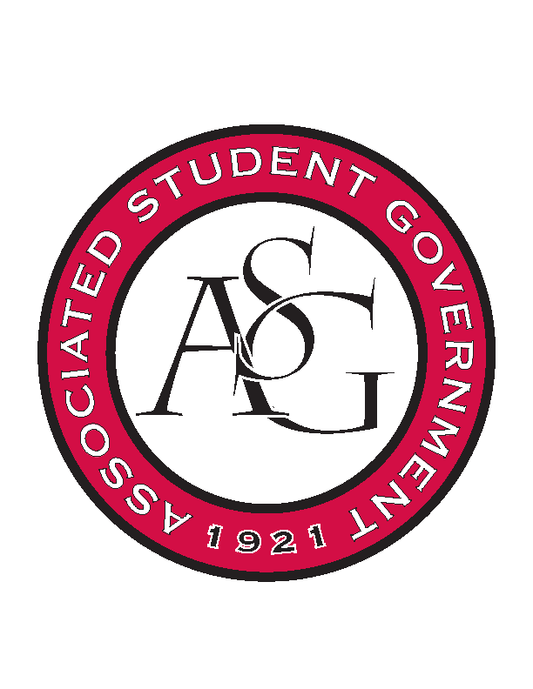
Associated Student Government

RSO Financial Affairs Meeting Agenda
April 13th, 2017

- Call To Order
  - (5:01)
- Roll Call
  - Adam Jones
  - Jacob Stansell
  - Macarena Arce
  - Jalen Hemphill
  - Isamar Garcia
  - Paige Ooton
  - Colton Smith
  - Drew Maney
      - Proxy: Dani Zapata
  - Ramon Silvera
- Approval of the Minutes
- Appeal
  - The Higher Education Organization
      - Deny (9-0)
- Audit Reports
- Old Business
- New Business
  - Wanderlust und Gemütlichkeit: The University of Arkansas German Club
      - Late
      - Deny (9-0)
  - InterVarsity Christian Fellowship
      - Late
      - Deny (9-0)
  - Mortar Board National Senior Honor Society
      - Late
      - Deny (9-0)
  - Ascend--University of Arkansas Student Chapter
      - Change cans to 2 liters
      - Water bottles too expensive
      - Recruitment max is $111.75
      - Cute $190 down to $111.75
      - Can change food options if they so choose
      - Approved (9-0)
  - Simple Truth
      - Late
      - Deny (9-0)
  - Contemporary Sculpture Society
      - Two days for hotel?
      - Fees for hillside
      - Set up and tear down time for event?
      - Approved (9-0)
  - Public Relations Student Society of America
      - Approved (9-0)
  - Biology Club
      - 2 liters decreased to $1.50
      - expensive pizzas?
      - Recruitment!
      - Removed sales tax
      - We do not fund meetings
      - Add required advertisements
      - Additional details about event itinerary
      - Delivery $3
      - Where are napkins and plates coming from?
- Announcements
- Adjournment
  - (5:27)

