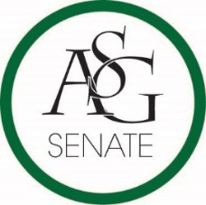
0
Senate Agenda
January 23rd, 2018
Graduate Education Auditorium, 6:00 PM
- Call to Order
- Roll Call
- Approval of the Minutes
- Special Orders
  - Reports (5 minutes each)
    - Special Reports
    - Advisor, Michael McAllister
    - Graduate Assistants, Joshua Saraping and Sage McCoy
    - President, Andrew Counce
    - Vice-President, Natalie Counce
    - Treasurer, Macarena Arce
    - Secretary, Ashton Yarborough
    - Chief Justice, Andrew Hansen
    - GSC Speaker, Arley Ward
    - Cabinet Reports
      - Chief of Staff, JT Hale
    - FLF Coordinator, Abigail Walker
    - Chair of the Senate, Colman Betler
- Appointments, Nominations, and Elections
  - Christine Carroll Confirmation
- Public Comment (3 at 2 minutes each)
- Old Business
  - ASG Joint Resolution No. 9 - A Resolution to Support the Replacement of the Student Travel Video
    - Authored by Senator Mateo Lopez and FLF member Esteban Lopez
    - Sponsored by Senator Drake Moudy, Senator Brandon Davis, Senator Zane Lovell, Senator Clay Smith and Senator Jesse Kloss
- New Business
  - ASG Senate Bill No. 05 - A Bill Funding the Enshrinement of the Old Main Oath in the Union
    - Authored by Senator Jared Pinkerton, Senator Caroline Dallas, Senator Luke Turner, Co-Director of Academic Affairs Spencer Bone, Senator Josie DuBois
    - Sponsored by Chair of Senate Colman Betler
- Announcements
- Adjournment

