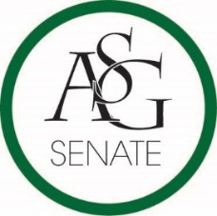
0
Senate Agenda
March 6th, 2018
Graduate Education Auditorium, 6:00 PM
- Call to Order
- Roll Call
- Approval of the Minutes
- Special Orders
  - Reports (5 minutes each)
    - Special Reports
      - Director of Transit and Parking, Gary Smith
    - Advisor, Michael McAllister
    - Graduate Assistants, Joshua Saraping and Sage McCoy
    - President, Andrew Counce
    - Vice-President, Natalie Counce
    - Treasurer, Macarena Arce
    - Secretary, Ashton Yarborough
    - Chief Justice, Andrew Hansen
    - GSC Speaker, Arley Ward
    - Cabinet Reports
      - Chief of Staff, JT Hale
    - FLF Coordinator, Abigail Walker
    - Chair of the Senate, Colman Betler
- Appointments, Nominations, and Elections
  - Chair of Senate Nominee Speeches
    - Clay Smith
    - Colman Betler
  - Chair of Senate Election
- Public Comment (3 at 2 minutes each)
- Old Business
  - ASG Senate Resolution No. 12 - A Resolution to Support the Charter of Free Food Mobile App on Campus
    - Authored by Guy Shamwol, Moses Agare
    - Sponsored by Senator Thea Winston, Sen. Brandon Davis, Sen. Karsen Sims, Sen. Emma Cleaver, Sen. Blaine Fielder, Sen. Mateo Lopez
- New Business
- Announcements
- Adjournment

