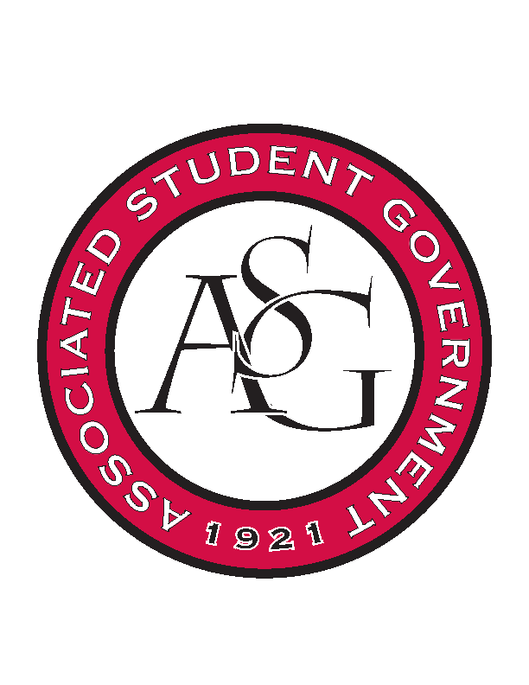
Associated Student Government

Office of Financial Affairs Meeting Agenda
January 18, 2018

- Call To Order
- Roll Call
- Approval of the Minutes
- Appeals
- Audit Reports
- Tabled
  - Biomedical Engineering Society
- Old Business
- New Business
  - UA Swing Kids
  - American Society of Civil Engineers
  - Block and Bridle
  - Institute of Industrial and Systems Engineers
  - Biology Graduate Student Association Conference 1
  - Biology Graduate Student Association Conference 2
  - Biology Graduate Student Association Conference 3
  - Women's Law Student Association
  - American Society of Interior Designers
  - Wanderlust und Gemütlichkeit: German Club
- Announcements
- Adjournment

