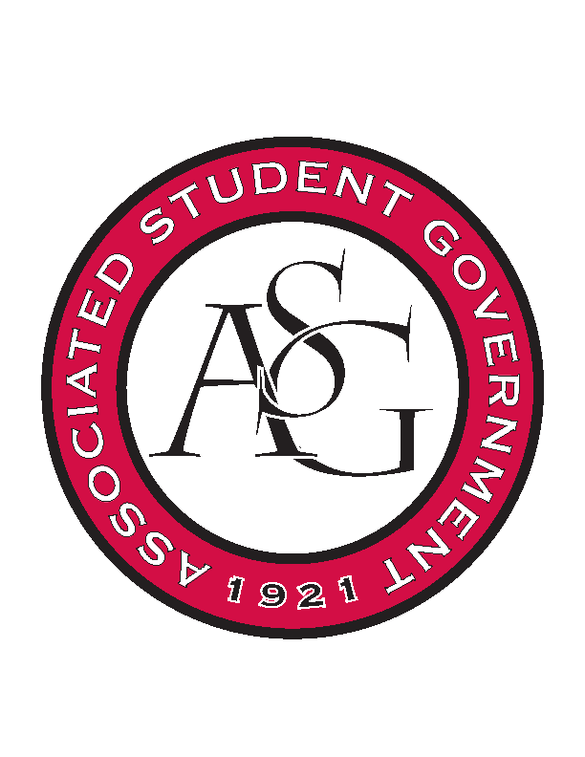
Associated Student Government

Office of Financial Affairs Meeting Agenda
December 7, 2017

- Call To Order
- Roll Call
- Approval of the Minutes
- Appeals
- Audit Reports
- Old Business
  - Biomedical Engineering Society
  - Chi Epsilon
  - Horticulture Club
  - Kappa Kappa Psi
  - American Constitution Society
- New Business
  - UArk Speedsolving Club
- Announcements
  - Please remember to do audits!
  - Goodbye to Andrew and Kadarius
  - Two new Board Members
  - Two new Proxies
  - Superlatives
- Adjournment

