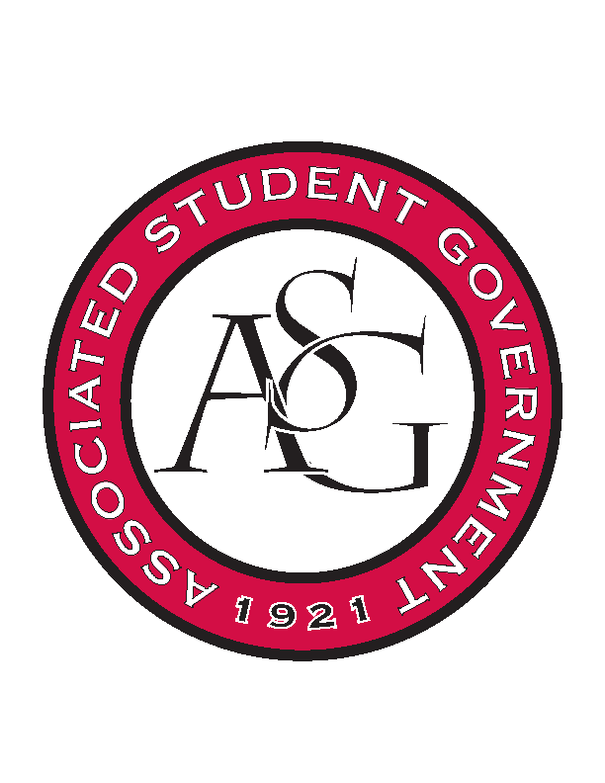
Associated Student Government

Office of Financial Affairs Meeting Agenda
January 18, 2018

- Call To Order
  - 5:02
- Roll Call
  - Adam Jones
  - Colin Gonzalez
  - Jalen Hemphill
  - Kyle Ward
  - Peyton Podschwit
      - Proxy: Dani Zapata
  - Ploy Pleetissamuth
  - Semien Hagos
  - Sofia Hadley
      - Absent
  - William Neely
Proxies
  - Dani Zapata
  - Kate Hedgecock
  - Madeline Brown
  - Marco Gargano
- Approval of the Minutes
- Appeals
- Audit Reports
- Tabled
  - Biomedical Engineering Society
      - Approved (5-3)
- Old Business
- New Business
  - UA Swing Kids
      - Approved (8-0)
  - American Society of Civil Engineers
      - Approved (8-0)
  - Block and Bridle
      - On Time
      - Approved (8-0)
  - Institute of Industrial and Systems Engineers
      - Found a $70 registration fee
      - Could not find a deadline on the website
      - Is this a competition – are there any rewards?
        - Approved (8-0)
  - Biology Graduate Student Association Conference 1
      - Approved (8-0)
  - Biology Graduate Student Association Conference 2
      - Approved (8-0)
  - Biology Graduate Student Association Conference 3
      - Approved (8-0)
  - Women's Law Student Association
      - Late
      - Denied (0-8)
  - American Society of Interior Designers
      - Late
      - Denied (0-8)
  - Wanderlust und Gemütlichkeit: German Club
      - Approved (7-1)
- Announcements
- Adjournment
  - 5:37

