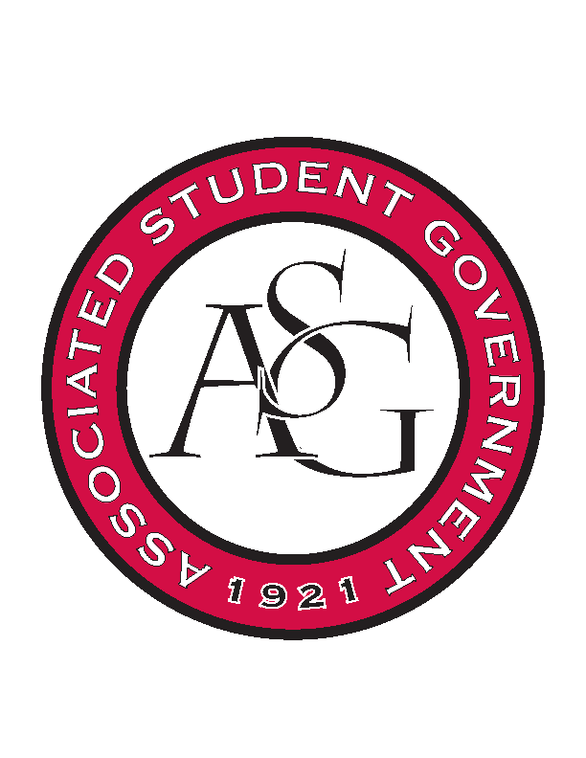
Associated Student Government

Office of Financial Affairs Meeting Agenda
December 7, 2017

- Call To Order
- Roll Call
a. Adam Jones
b. Andrew Estes
c. Colin Gonzalez
d. Jalen Hemphill
e. Kyle Ward
f. Kadarius
g. Peyton Podschwit
h. Semien Hagos
i. Sofia Hadley
Proxies
j. Kate Hedgecock
k. Madeline Brown
l. William Neely
- Approval of the Minutes
- Appeals
- Audit Reports – See Audit Forms (Hogz End Alz Recruitment Event & Non-Traditional Pre-Med Recruitment)
- Old Business
  - Biomedical Engineering Society – Did not respond to Macarena’s email. We had several questions. 0-9 denied
  - Chi Epsilon – 9-0 approved
  - Horticulture Club – This is a University facility and should be maintained by the University. An RSO should not be responsible for repairs and maintenance of University owned buildings. We can make suggestions to them to ask for an educational event. 0-9 denied
  - Kappa Kappa Psi – 9-0 approved
  - American Constitution Society – additional hotel night (two speakers and one night apiece)
      - Cutting the budget to one night only approved (9-0)
      - Second round approved (9-0)
- New Business
  - UArk Speedsolving Club –
      - One day late
      - Denied (0-9)
- Announcements
  - Please remember to do audits!
  - Goodbye to Andrew and Kadarius
  - Two new Board Members
  - Two new Proxies
  - Superlatives
- Adjournment 5:29pm

