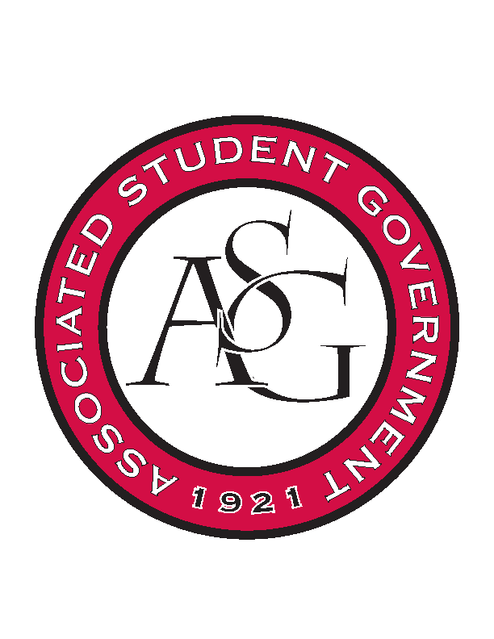
Associated Student Government

Office of Financial Affairs Meeting Agenda
February 1, 2018

- Call To Order
- Roll Call
- Approval of the Minutes
- Appeals
- Audit Reports
- Old Business
  - UA Swing Kids
  - American Society of Civil Engineers
  - Sports and Entertainment Law Society – need pre-event
  - Block and Bridle
  - Institute of Industrial and Systems Engineers
  - Biology Graduate Student Association Conference 1
  - Biology Graduate Student Association Conference 2
  - Biology Graduate Student Association Conference 3
  - Wanderlust und Gemütlichkeit: German Club
- New Business
  - The Higher Education Organization
  - American Society of Interior Designers
  - UA Photographic Society
  - Biological Engineering Student Club
  - Federalist Society
  - Electrochemical Society - University of Arkansas student chapter
  - If Gathering
  - Tau Beta Pi
  - Graduate Students in English
  - Il Circolo Italiano
- Announcements
  - Funding Sessions
  - FLF Presentation
- Adjournment

