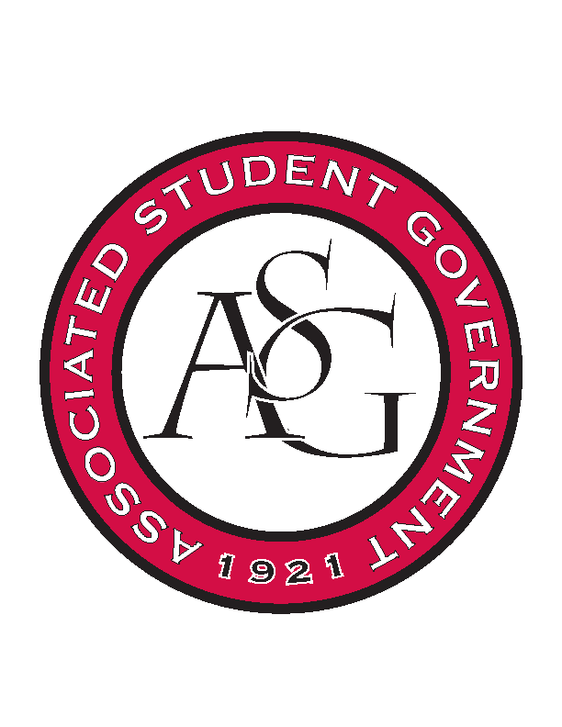
Associated Student Government

Office of Financial Affairs Meeting Agenda
February 1, 2018

- Call To Order
- Roll Call
- Approval of the Minutes
- Appeals
- Audit Reports
- Old Business
  - American Society of Interior Designers
  - UA Photographic Society
  - Biological Engineering Student Club
  - Electrochemical Society - University of Arkansas student chapter
  - If Gathering
  - Tau Beta Pi
  - Graduate Students in English
  - Il Circolo Italiano
- New Business
  - Minorities in Agriculture, Natural Resources, and Related Sciences
  - Geo-Institute Graduate Student Organization
  - Society of Hispanic Professional Engineers
  - Student Nurses Association
  - Women 4 Women
  - Caribbean Student Association
  - National Society of Black Engineers
- Announcements
  - Funding Sessions
  - FLF Presentation
- Adjournment

