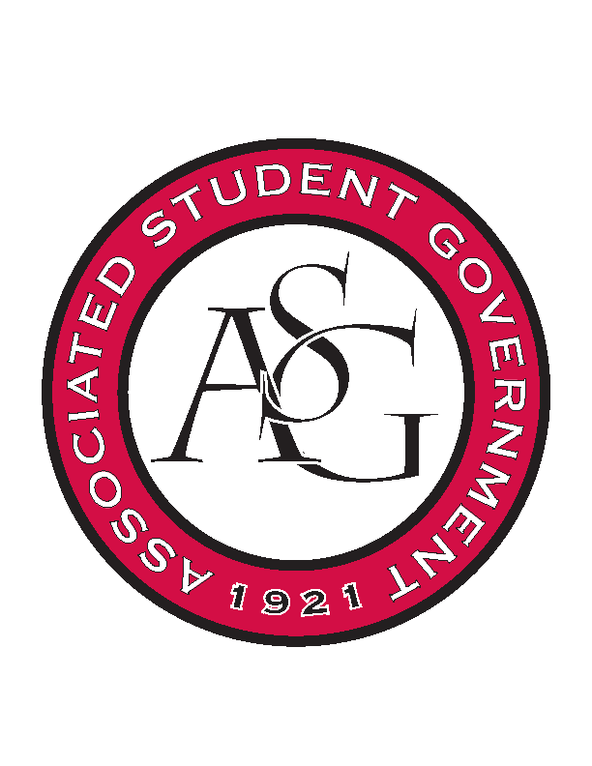
Associated Student Government

Office of Financial Affairs Meeting Agenda
February 15, 2018

- Call To Order
- Roll Call
- Approval of the Minutes
- Appeals
- Audit Reports
  - Chinese Students and Scholars
  - American Constitution Society
- Old Business
  - Net Impact
  - Japanese Student Association
  - African Students Organization
  - Drawing and Painting Association
  - Association of Ceramic Enthusiasts
  - Panamanian Student Organization
  - Agro-Panama International
  - Society of Art Historians
  - Space and Planetary Association for Collaboration and Education Hogs
- New Business
  - Pakistani Students Association
  - Space and Planetary Association for Collaboration and Education Hogs
  - Horticulture Club
  - American Marketing Association
  - Association of Ceramic Enthusiasts
  - Simple Truth
  - International Students Organization
  - Pre-Dental Society
- Announcements
  - Funding Sessions
- Adjournment

