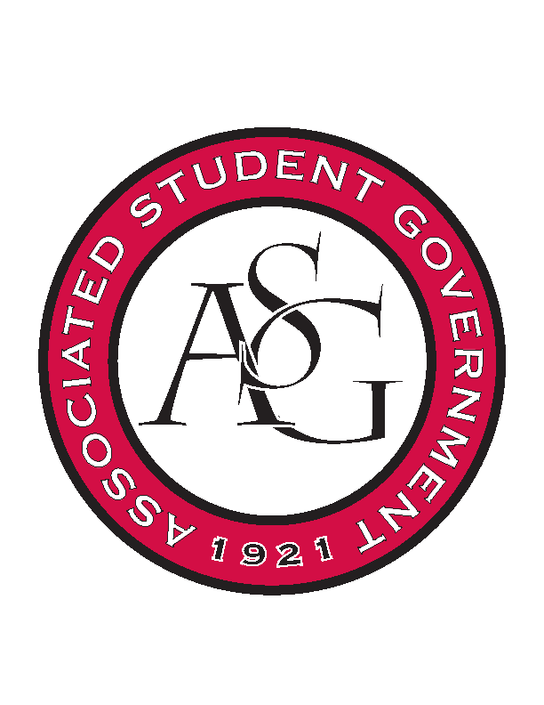
Associated Student Government

Office of Financial Affairs Meeting Agenda
February 22, 2018

- Call To Order
- Roll Call
- Approval of the Minutes
- Appeals
- Audit Reports
  - Chinese Students and Scholars
  - American Constitution Society
- Old Business
  - Pakistani Students Association
  - Horticulture Club
  - American Marketing Association
  - Association of Ceramic Enthusiasts
  - Simple Truth
  - International Students Organization
  - Pre-Dental Society
- New Business
  - Society of Women Engineers
  - Friends of India
  - Tau Beta Sigma
  - Kappa Kappa Psi
  - Geo-Institute Graduate Student Organization
  - Biomedical Engineering Society
  - Chess Club
  - InterVarsity Christian Fellowship
  - American Society of Interior Designers - Conference
  - Association of Graduate Student Artists
  - Gamma Eta Sorority, Inc.
  - American Society of Interior Designers – Event
  - Chinese Language and Culture Club
  - Hindu Students Association
  - Student Sierra Coalition at the University of Arkansas
  - Students of Retailing Excellence
  - ASCEND at the University of Arkansas
- Announcements
  - Funding Sessions
- Adjournment

