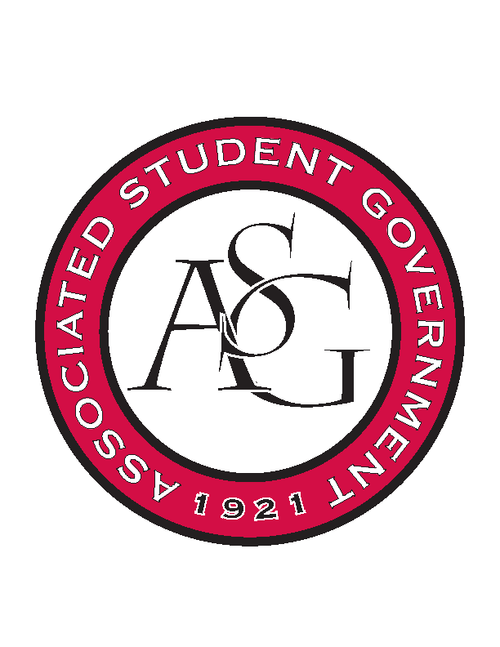
Associated Student Government

Office of Financial Affairs Meeting Agenda
February 8, 2018

- Call To Order
- Roll Call
- Approval of the Minutes
- Appeals
  - Electrochemical Society - University of Arkansas student chapter
- Tabled
  - If Gathering
- Audit Reports
- Old Business
  - Minorities in Agriculture, Natural Resources, and Related Sciences
  - Geo-Institute Graduate Student Organization
  - Student Nurses Association
  - Women 4 Women
  - Caribbean Student Association
  - National Society of Black Engineers
- New Business
  - Net Impact
  - Japanese Student Association
  - African Students Organization
  - Drawing and Painting Association
  - Association of Ceramic Enthusiasts
  - Panamanian Student Organization
  - Agro-Panama International
  - Society of Art Historians
  - Space and Planetary Association for Collaboration and Education Hogs
- Announcements
  - Funding Sessions
  - FLF Presentation
- Adjournment

