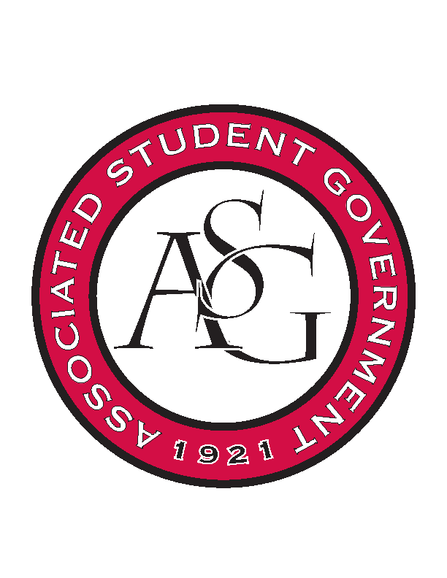
Associated Student Government

Office of Financial Affairs Meeting Agenda
February 15, 2018

- Call To Order
- Roll Call
  - Adam Jones
  - Colin Gonzalez
      - Absent
  - Jalen Hemphill
  - Kyle Ward
  - Peyton Podschwit
      - Proxy: Marco
  - Ploy Pleetissamuth
  - Semien Hagos
      - Proxy: Kadarius
  - Sofia Hadley
  - William Neely
Proxies
  - Dani Zapata
  - Kate Hedgecock
  - Madeline Brown
  - Marco Gargano
  - Kadarius
- Approval of the Minutes
- Appeals
- Audit Reports
  - Chinese Students and Scholars
  - American Constitution Society
- Old Business
  - Net Impact
      - Second Round Approved (6-0)
  - Japanese Student Association
      - Second Round Approved (6-0)
  - African Students Organization
      - Second Round Approved (6-0)
  - Drawing and Painting Association
      - Removing miscellaneous and catering
      - Second Round Approved (7-0)
  - Association of Ceramic Enthusiasts
      - Second Round Approved (7-0)
  - Panamanian Student Organization
      - Motion to table approved (7-0)
  - Agro-Panama International
      - Motion to table approved (7-0)
  - Society of Art Historians
      - Second Round Approved (7-0)
  - Space and Planetary Association for Collaboration and Education Hogs
      - Second Round Approved (7-0)
- New Business
  - Pakistani Students Association
      - Why two nights?
      - How many drinks?
      - Cap is $12 for attendee
      - Venue Fees
      - Prices of miscellaneous items
      - First Round Approved (8-0)
  - Space and Planetary Association for Collaboration and Education
Hogs
      - Late
      - Denied (0-8)
  - Horticulture Club
      - Approved (8-0)
  - American Marketing Association
      - What are the awards?
      - What is the due date?
      - First Round Approved (8-0)
  - Association of Ceramic Enthusiasts
      - When will he be meeting with students individually?
      - Why two nights?
      - Who is the workshop for?
      - Cannot sell anything/receive money
      - Who are the co-sponsors?
      - No non-students?
      - Exclusive?
      - First Round Approved (7-1)
  - Simple Truth
      - What will be happening in their education sessions?
      - Encourage underclassmen to attend these events
      - First round approved (8-0)
  - International Students Organization
      - Any co-sponsors?
      - Only 15 non-students?
      - Ask for agenda
      - $990 – ask about any extra fees
      - First round approved (7-1-0)
  - Pre-Dental Society
      - First Round Approved (8-0)
- Announcements
  - Funding Sessions
- Adjournment

