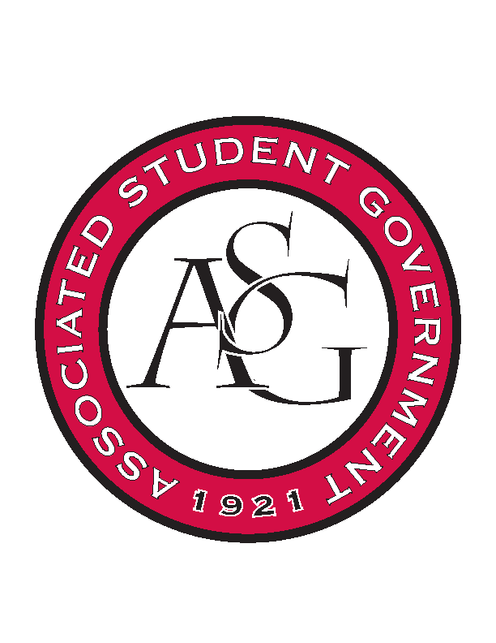
Associated Student Government

Office of Financial Affairs Meeting Agenda
February 22, 2018

- Call To Order
- Roll Call
  - Adam Jones – present
  - Colin Gonzalez – present
  - Jalen Hemphill – present
  - Kyle Ward – present
  - Peyton Podschwit – present
  - Ploy Pleetissamuth –present
  - Semien Hagos – present
  - Sofia Hadley – present
  - William Neely –proxy – Kate Hedgecock
Proxies
  - Dani Zapata
  - Kate Hedgecock
  - Madeline Brown
  - Marco Gargano
  - Kadarius
- Approval of the Minutes
- Appeals
- Audit Reports
  - Chinese Students and Scholars
  - American Constitution Society – Human Trafficking Event
- Old Business
  - Pakistani Students Association
      - Speaker flying from New Jersey (approved for 2 nights)
      - Cut cutlery expenses to $20 from $34
      - Changed Water and soda from $180 to $82.50
      - Approved 9 – 0
  - Horticulture Club
      - Approved at $75 for 3 students as submitted
      - Approved 9-0
  - American Marketing Association
      - Approved 9-0
  - Association of Ceramic Enthusiasts
      - Cut to 1 night
      - Cut per diem to 1 day
      - Workshop is exclusive
      - Approved 9-0
  - Simple Truth
      - Approved 9-0
  - International Students Organization
      - Approved 7-0-2
  - Pre-Dental Society
      - Approved 9-0
- New Business
  - Society of Women Engineers
      - What specific activities will take place?
      - Networking – need to cut to $500
      - Make sure this event is inclusive to all students
      - Add 2 guest speakers to food count (non-students)
      - Approved 7-2
  - Friends of India
      - Water Bottles are part of the $12/person cap
      - Details on food – menu cannot be TDB
      - Why only 265 for food count?
      - What is transportation cost?
      - What activities are taking place?
      - How much water and how many?
      - How many plates, cups at what price?
      - Water must be separate from plates/forks/knives?
      - Approved 9-0
  - Tau Beta Sigma
      - No due date listed on conference website
      - Approved 9-0
  - Kappa Kappa Psi
      - No due date listed on conference website
      - 12 @ $45 listed - $540
      - What are the awards?
      - Approved 9-0
  - Geo-Institute Graduate Student Organization
      - This event is exclusive to Civil Engineering
      - Denied 9-0
  - Biomedical Engineering Society
      - Need more detail on food
      - What’s included in the taco bar
      - Approved 9-0
  - Chess Club
      - Cannot purchase trophies, awards, raffles, chess equipment, chess clocks etc.
      - Must have an exact estimate on how many students are attending
      - Pizza – where is it coming from and how much per pizza
      - Raffles are not allowed by university policy
      - Cut everything except pizza costs
      - Approved 7-2
  - InterVarsity Christian Fellowship
      - Conferences cap at $1500
      - Approved 9-0
  - American Society of Interior Designers – Conference
      - Late
      - Denied 9-0
  - Association of Graduate Student Artists
      - What is misc. fee?
      - Funding Honorarium only - $700?
      - Can only pay the speaker an honorarium and not workshop items.
      - Approved 9-0
  - Gamma Eta Sorority, Inc.
      - What is happening at this event? We need more details on this event.
      - $98 for connections lounge?
      - Why 10 table skirts and 9 tables?
      - Approved 9-0
  - American Society of Interior Designers – Conference
      - Late
      - Denied 9-0
  - Chinese Language and Culture Club
      - Cut to $20 Admin Expense
      - Encourage RSO to apply for Recruitment Event
      - Approved 9-0
  - Hindu Students Association
      - MiFiesta is not an approved vendor.
      - What are the inflatables for? We are cutting these items.
      - What educational value does the inflatable have/obstacle course, and gladiator jousting?
      - Request them to attend 3/1 OFA meeting should they wish to explain
      - $90 water? How much water and at what price?
      - Napkins $20? How many napkins and where are you getting them from?
      - $1600 for food for students only
      - Approved 9-0
  - Student Sierra Coalition at the University of Arkansas
      - What do they do during the workshops?
      - Explain the educational value of the workshops.
      - Approved 7-0-1
  - Students of Retailing Excellence
      - do not pay for parking
      - Would like to know more about each guest/biography for each person.
      - Are they paying for guests to eat?
      - Approved 8-0
  - ASCEND at the University of Arkansas
      - Networking Event
      - 330 plates? Cut to 100 plates (Suggest to get plates from Walmart )
      - Need one of the emails for one of the panelists that’s missing.
      - Approved 7-0-1
- Announcements
  - Funding Sessions
- Adjournment

