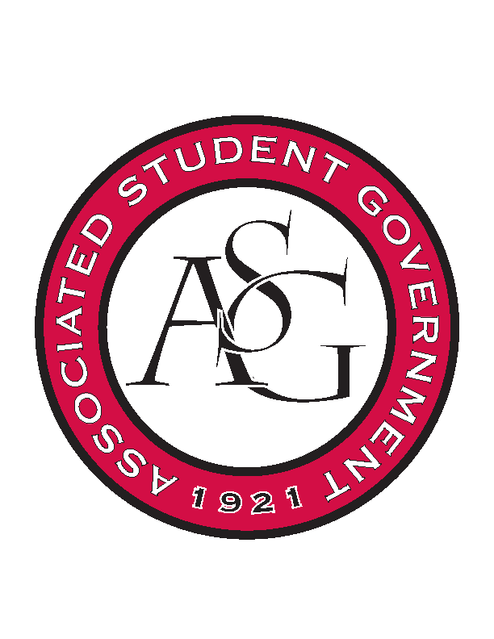
Associated Student Government

Office of Financial Affairs Meeting Agenda
February 8, 2018

- Call To Order
- Roll Call
  - Adam Jones
  - Colin Gonzalez
  - Jalen Hemphill
  - Kyle Ward
  - Peyton Podschwit
  - Ploy Pleetissamuth
  - Semien Hagos
  - Sofia Hadley
  - William Neely
Proxies
  - Dani Zapata
  - Kate Hedgecock
  - Madeline Brown
  - Marco Gargano
  - Kadarius
- Approval of the Minutes
- Appeals
  - Electrochemical Society - University of Arkansas student chapter
      - Everything is still tentative and that is an issue with the money
      - Denied (0-8)
- Tabled
  - If Gathering
      - Second round approved (5-3)
- Audit Reports
- Old Business
  - Minorities in Agriculture, Natural Resources, and Related Sciences
      - Second round approved (6-0)
  - Geo-Institute Graduate Student Organization
      - Second round approved (8-0)
  - Student Nurses Association
      - Second round approved (7-0-1)
  - Women 4 Women
      - Second round approved (8-0)
  - Caribbean Student Association
      - Vote to cut tablecloth (6-2)
      - Second round approved (8-0)
  - National Society of Black Engineers
      - Second round approved (8-0)
- New Business
  - Net Impact
      - Ask about Chipotle
      - Is the person who applied still the president?
      - First Round Approved (8-0)
  - Japanese Student Association
      - What are you teaching?
      - Program or schedule
      - Approved (8-0)
  - African Students Organization
      - Cut tickets to $50
      - Is the DJ necessary?
      - What is the educational value?
      - Approved (8-0)
  - Drawing and Painting Association
      - Need to provide a short bio
      - Why 2 nights?
      - $1000 – have you checked flight costs from Atlanta
      - Co-Sponsorships?
      - Define Misc. Purchases
      - Food for 2nd day is exclusive for select students
      - Approved (8-0)
  - Association of Ceramic Enthusiasts
      - Can only fund $1500 for conference registration
      - Approved (7-0)
  - Panamanian Student Organization
      - High schoolers? Is this ticketed or not? Non-student attendees
      - How do you expect this many people to attend? Advertising methods?
      - Approved (7-0)
  - Agro-Panama International
      - Cut uplights from budget (7-0)
      - Approved (7-0)
  - Society of Art Historians
      - Why 2 nights?
      - Any co-sponsorships?
      - Approved (7-0)
  - Space and Planetary Association for Collaboration and Education Hogs
      - Approved (7-0)
- Announcements
- Adjournment

