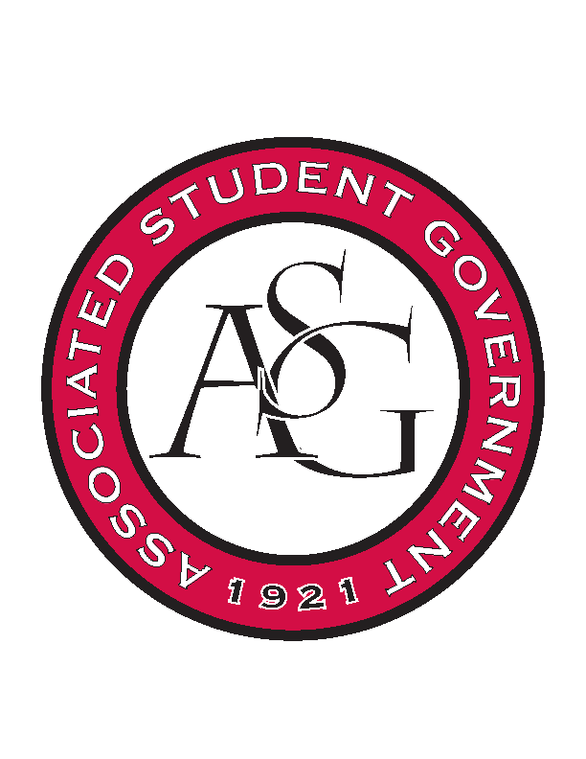
Associated Student Government

Office of Financial Affairs Meeting Agenda
March 1, 2018

- Call To Order
- Roll Call
- Approval of the Minutes
- Appeals
  - Geo-Institute Graduate Student Organization
- Audit Reports
  - Hogs End Alz
- Old Business
  - Society of Women Engineers
  - Friends of India
  - Tau Beta Sigma
  - Kappa Kappa Psi
  - Biomedical Engineering Society
  - Chess Club
  - InterVarsity Christian Fellowship
  - Association of Graduate Student Artists
  - Gamma Eta Sorority, Inc.
  - Chinese Language and Culture Club
  - Hindu Students Association
  - Student Sierra Coalition at the University of Arkansas
  - Students of Retailing Excellence
  - ASCEND at the University of Arkansas
- New Business
  - Biology Graduate Student Association
  - American Institute of Chemical Engineers
  - IEEE Power Electronics Society
  - Theta Tau
  - Arkansas Trial Lawyers Association
  - Nepali Association of Northwest Arkansas
  - Muslim Students Association
  - AIGA Student Group at the University of Arkansas
  - Tau Beta Pi
  - Muslima of UARK
- Announcements
  - Funding Sessions
  - Town Hall Debate Tonight!
- Adjournment

