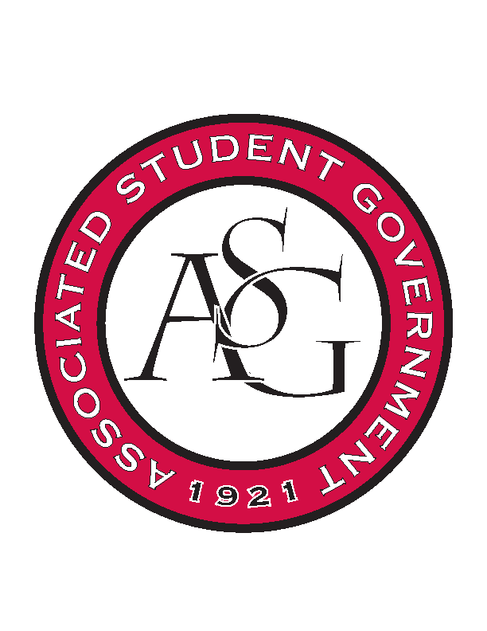
Associated Student Government

Office of Financial Affairs Meeting Agenda
March 15, 2018

- Call To Order
- Roll Call
- Approval of the Minutes
- Appeals
  - Biology Club
- Audit Reports
- Old Business
  - UARK Music Performers Producers & Professionals
  - Panamanian Student Organization
  - Agro-Panama International
  - Space and Planetary Association for Collaboration and Education Hogs
  - Environmental Law Society
  - Public Relations Student Society of America
  - Cultures and Dialogues
  - Iranian Students Association
  - Mental Health Awareness Organization
  - Al-Islam Student Association
  - Arkansas Consortium for European Studies
  - Non-traditional Premedical Student Organization
- New Business
  - Russian-Eurasian Student Organization
  - IEEE Women in Engineering Student Branch Affinity Group at the University of Arkansas
  - Wanderlust und Gemütlichkeit: German Club
  - Electrochemical Society - University of Arkansas student chapter – Conference
  - Electrochemical Society - University of Arkansas student chapter – Event
  - Advertising Club
  - Arkansas Chemical Engineering Graduate Students
  - Young Democrats
  - UARK Gaming
- Announcements
  - Funding Sessions
  - Remember to do audits!
  - Have a safe and happy Spring Break!
- Adjournment

