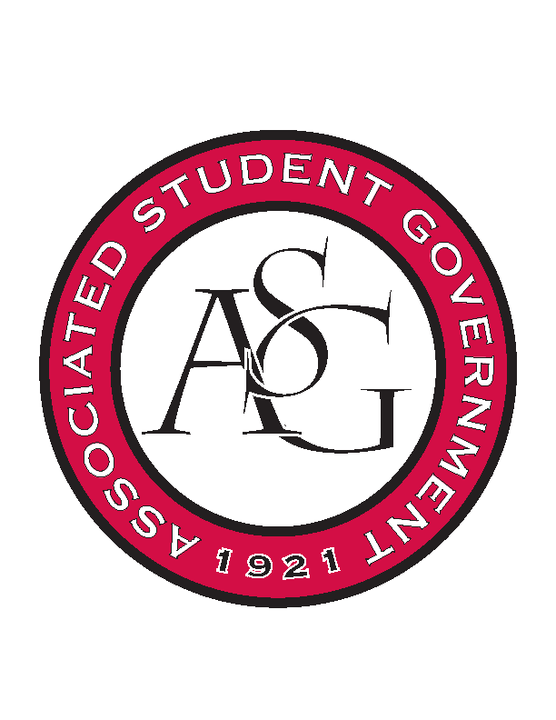
Associated Student Government

Office of Financial Affairs Meeting Agenda
March 8, 2018

- Call To Order
- Roll Call
- Approval of the Minutes
- Appeals
  - Tau Beta Pi
- Audit Reports
- Old Business
  - Hindu Students Association – add non-students
  - Biology Graduate Student Association
  - American Institute of Chemical Engineers
  - IEEE Power Electronics Society
  - Nepali Association of Northwest Arkansas
  - Muslim Students Association
  - AIGA Student Group at the University of Arkansas
  - Muslima of UARK
- New Business
  - UARK Music Performers Producers & Professionals
  - Panamanian Student Organization
  - Biology Club
  - Agro-Panama International
  - Space and Planetary Association for Collaboration and Education Hogs
  - Environmental Law Society
  - Public Relations Student Society of America
  - Cultures and Dialogues
  - Iranian Students Association
  - Pi Sigma Alpha
  - Electrochemical Society - University of Arkansas student chapter
  - Mental Health Awareness Organization
  - IEEE Women in Engineering Student Branch Affinity Group at the University of Arkansas
  - Al-Islam Student Association
  - Arkansas Consortium for European Studies
  - Non-traditional Premedical Student Organization
- Announcements
  - Funding Sessions
  - Remember to do audits!
- Adjournment

