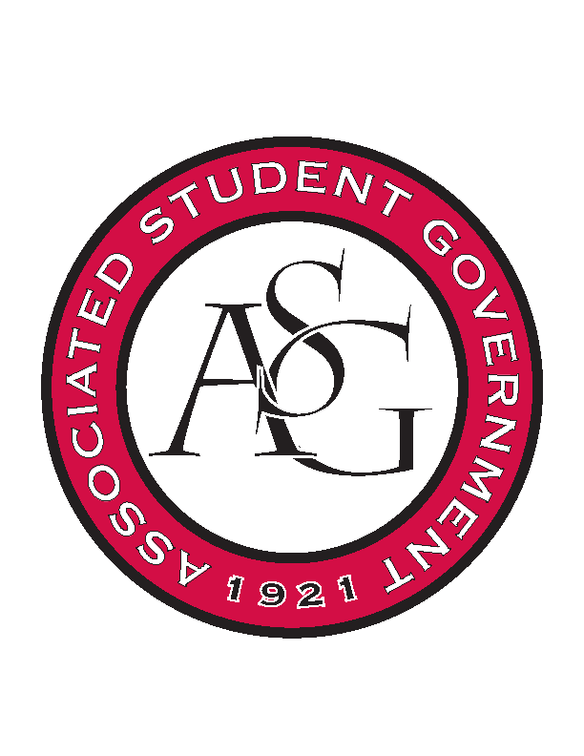
Associated Student Government

Office of Financial Affairs Meeting Minutes
March 15, 2018

- Call To Order
- Roll Call
  - Adam Jones
  - Colin Gonzalez
  - Jalen Hemphill
      - absent
  - Kyle Ward
  - Peyton Podschwit
  - Ploy Pleetissamuth
  - Semien Hagos
  - Sofia Hadley
  - William Neely
Proxies
  - Dani Zapata
  - Kate Hedgecock
  - Madeline Brown
  - Marco Gargano
  - Kadarius Toussaint
- Approval of the Minutes
- Appeals
  - Biology Club
- Audit Reports
- Old Business
  - UARK Music Performers Producers & Professionals
      - 30 + 5 students attending total 35
      - Second round approved (8-0)
  - Panamanian Student Organization
      - Will make sure to let everyone know that everyone is welcomed
      - Second round approved (8-0)
  - Agro-Panama International
      - Second round approved without the bull (8-0)
  - Space and Planetary Association for Collaboration and Education Hogs
      - Second round approved (8-0)
  - Environmental Law Society
      - Late was denied last week
  - Public Relations Student Society of America
      - Never responded to questions
      - Denied (1-6-1)
  - Cultures and Dialogues
      - Never responded to questions
      - Denied (0-6-2)
  - Iranian Students Association
      - Second round approved (7-1)
  - Mental Health Awareness Organization
      - Motion to cut buttons
        - Approved (7-1)
      - Second round approved (8-0)
  - Al-Islam Student Association
      - Motion to add 7 non-students
        - Approved (8-0)
      - Second round approved (8-0)
  - Arkansas Consortium for European Studies
      - Second round approved (8-0)
  - Non-traditional Premedical Student Organization
      - Motion to add three students
        - Approved (8-0)
      - Second round approved (8-0)
- New Business
  - Russian-Eurasian Student Organization
      - Need to ask if speaker is a U.S. citizen
      - Approved (8-0)
  - IEEE Women in Engineering Student Branch Affinity Group at the University of Arkansas
      - First round approved (8-0)
  - Wanderlust und Gemütlichkeit: German Club
      - Very vague (what pizza? Snacks? Gathering?)
      - Not educational
      - Denied (0-8)
  - Electrochemical Society - University of Arkansas student chapter – Conference
      - Approved (8-0)
  - Electrochemical Society - University of Arkansas student chapter – Event
      - How is this applicable to other students?
      - Make sure it’s marketed to all students
      - Approved (8-0)
  - Advertising Club
      - Motion to cut the badges
        - Approved (8-0)
      - Cannot pay the musicians because they are students
      - Why two nights?
      - Who is presenting?
      - Who is getting the honorarium?
      - Mandatory advertisement
      - Based on previous events, how do you plan on improving attendance?
      - Add the co-sponsors
      - Approved (8-0)
  - Arkansas Chemical Engineering Graduate Students
      - If they do not list any co-sponsors, they are not allowed to advertise anyone but ASG
  - Young Democrats
      - Late
      - Denied (0-8)
  - UARK Gaming
      - Cut attendance to 125 based on previous attendance
      - What games are you playing?
      - Cannot fundraise with raffles
      - If they are doing prizes, they must specify who funded them
      - Approved (8-0)
- Announcements
  - Funding Sessions
  - Remember to do audits!
  - Have a safe and happy Spring Break!
- Adjournment

