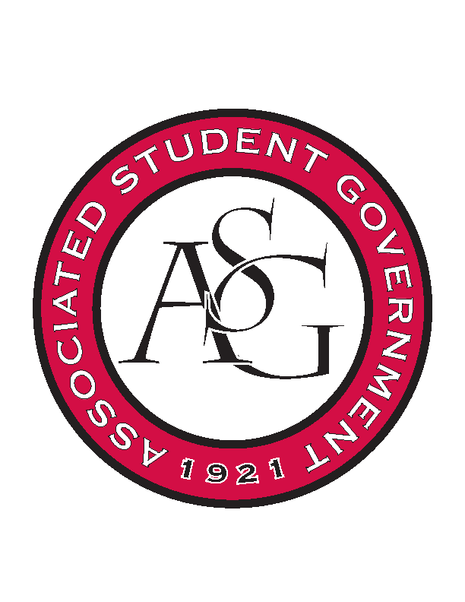
Associated Student Government

Office of Financial Affairs Meeting Agenda
April 12, 2018

- Call To Order
- Roll Call
- Approval of the Minutes
- Appeals
- Audit Reports
- Old Business
  - First Baptist Church Fayetteville Collegiate Group
- New Business
  - Phi Sigma Rho
  - UARK Gaming
  - Student Alumni Association
  - Greek Life Budget Portal - Zeta Phi Beta - Regional Conference
  - Greek Life Budget Portal - Zeta Phi Beta - Boule Conference
  - Greek Life Budget Portal - Zeta Phi Beta - Admin Funds
  - International Justice Mission at the University of Arkansas
  - Theta Tau
- Announcements
  - Remember to do audits!
- Standing Rules Meeting Second Reading
  - OFA Code
- Adjournment

