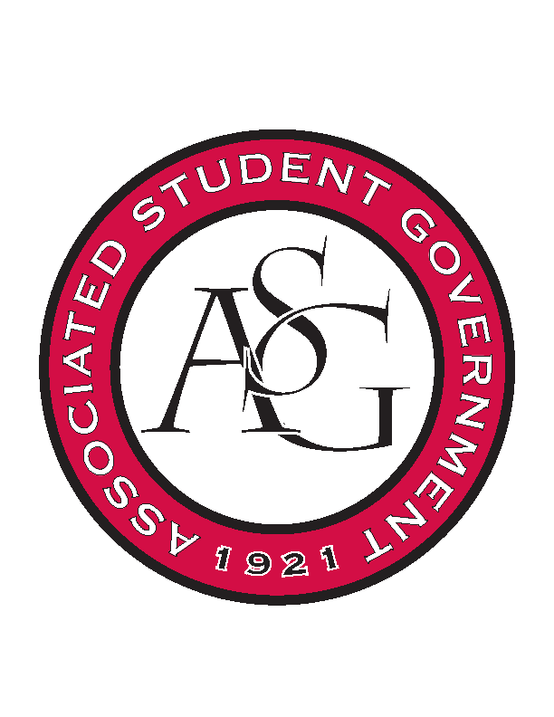
Associated Student Government

Office of Financial Affairs Meeting Agenda
April 5, 2018

- Call To Order
- Roll Call
- Approval of the Minutes
- Appeals
  - Chi Alpha
  - Light of Love
- Audit Reports
  - Colin
  - William
  - Kyle x 3
  - Izzy
  - Kadarius
- Old Business
  - People Respecting the Individual Differences and Equality
  - Filipino Students Organization
  - You Ought to Live Optimistically
  - Chinese Language and Culture Club – Event
  - Greek Life Budget Portal
- New Business
  - Phi Sigma Rho
  - First Baptist Church Fayetteville Collegiate Group
- Announcements
  - Remember to do audits!
- Standing Rules Meeting
  - OFA Code
- Adjournment

