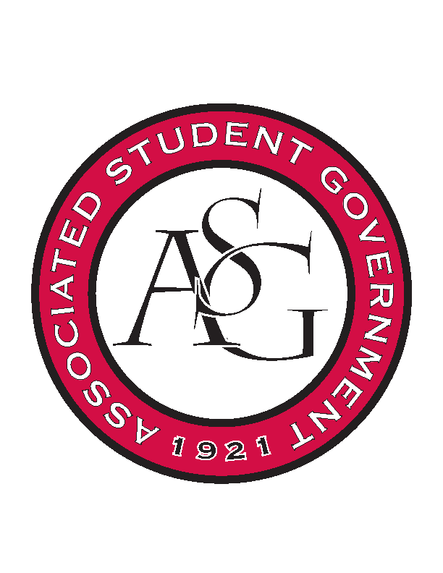
Associated Student Government

Office of Financial Affairs Meeting Agenda
April 12, 2018

- Call To Order
- Roll Call - Peyton –Proxy – Madeline Brown; Jalen H. – Kate H.– The rest of the board is here.
- Approval of the Minutes
- Appeals
- Audit Reports
- Old Business
  - First Baptist Church Fayetteville Collegiate Group – 8-0 denied
- New Business
  - Phi Sigma Rho - 9-0 approved
  - UARK Gaming – 9-0 approved
  - Student Alumni Association
      - Need to itemize what they are asking for (Misc. Purchases)
      - Lacks educational value
      - 9-0 denied
  - Greek Life Budget Portal - Zeta Phi Beta - Regional Conference
      - Can’t find due date – Due date May 16th
      - $210 – Conference Registration Fees
      - More details on additional tickets and training and why we should fund these items
      - 9-0 approved
  - Greek Life Budget Portal - Zeta Phi Beta - Boule Conference
      - Late
      - 9-0 denied
  - Greek Life Budget Portal - Zeta Phi Beta - Admin Funds
      - 9-0 approved
  - International Justice Mission at the University of Arkansas
      - Which price are you trying to use?
      - Why are you not using the student registration price? $99 due on 9/28.
      - April 30th deadline for non-students
        - Late at that date
      - 9-0 approved pending above information requested
  - Theta Tau Alpha
      - We need a specific number of attendees
      - 8-1 approved
- Announcements
  - Remember to do audits!
      - 3 audits for the Spring
- Standing Rules Meeting Second Reading
  - OFA Code
- Adjournment

