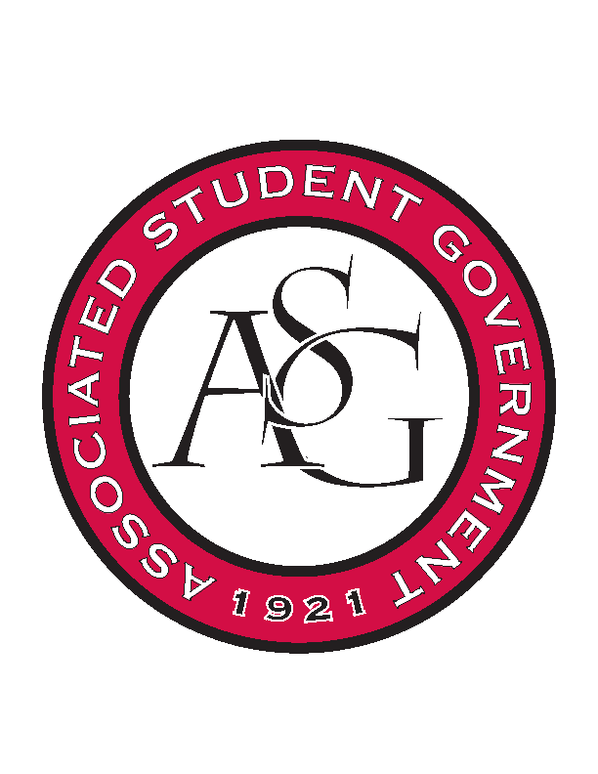
Associated Student Government

Office of Financial Affairs Meeting Minutes
April 5, 2018

- Call To Order
- Roll Call
  - Adam Jones
  - Colin Gonzalez
  - Jalen Hemphill
  - Kyle Ward
  - Peyton Podschwit
  - Ploy Pleetissamuth
  - Semien Hagos
      - Proxy: Madeline Brown
  - Sofia Hadley
  - William Neely
Proxies
  - Dani Zapata
  - Kate Hedgecock
  - Madeline Brown
  - Marco Gargano
  - Kadarius
- Approval of the Minutes
- Appeals
  - Chi Alpha
      - Appeal sounds like a completely different event
      - The plates are pottery
      - Consider resubmitting for another time
      - Denied (9-0)

  - Light of Love
      - Denied (9-0)
- Audit Reports
  - Colin
  - William
  - Kyle x 3
  - Izzy x 2
  - Kadarius
- Old Business
  - People Respecting the Individual Differences and Equality
      - Motion to cut lights
        - Approved (9-0)
      - Second round approved (9-0)
  - Filipino Students Organization
      - Chips and Snacks?
      - Water is not itemized
      - Board still believes this is just a game night
      - Games are not listed
      - Still not itemized
      - Did not get the information that we asked for
      - Agenda was not specific enough
      - Second round denied (9-0)
  - You Ought to Live Optimistically
      - Board believes tables and linens are okay
      - Second round approved (9-0)
  - Chinese Language and Culture Club – Event
      - No response about the kitchen reservation
      - Cannot fund an event without an approved kitchen
      - Denied (9-0)
  - Greek Life Budget Portal
      - Second round approved (8-0-1)
- New Business
  - Phi Sigma Rho
      - Vague website
      - Not much information about event or registration rate
      - Denied (9-0)
  - First Baptist Church Fayetteville Collegiate Group
      - Could not find the due date
      - Confirm the due dates for the prices – may forward email from the organizer
      - Approved (8-1)
- Announcements
  - Remember to do audits!
- Standing Rules Meeting
  - OFA Code
- Adjournment

