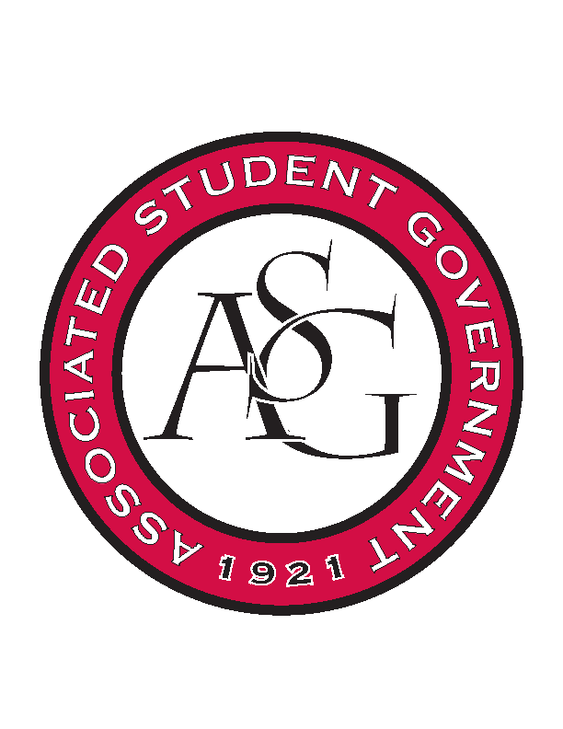
Associated Student Government

Office of Financial Affairs Meeting Agenda
April 19, 2018

- Call To Order
- Roll Call
- Approval of the Minutes
- Appeals
- Audit Reports
- Old Business
  - Phi Sigma Rho
  - UARK Gaming
  - Greek Life Budget Portal - Zeta Phi Beta - Regional Conference
  - Greek Life Budget Portal - Zeta Phi Beta - Admin Funds
  - International Justice Mission at the University of Arkansas
  - Theta Tau
- New Business
  - Alpha Epsilon Delta
  - Biological Engineering Student Club
  - Greek Life Budget Portal - Zeta Phi Beta - Regional Conference
  - ALPFA
  - Full Stomachs Clean Feet
  - Electrochemical Society - University of Arkansas student chapter
- Announcements
  - Remember to do audits!
- Adjournment

