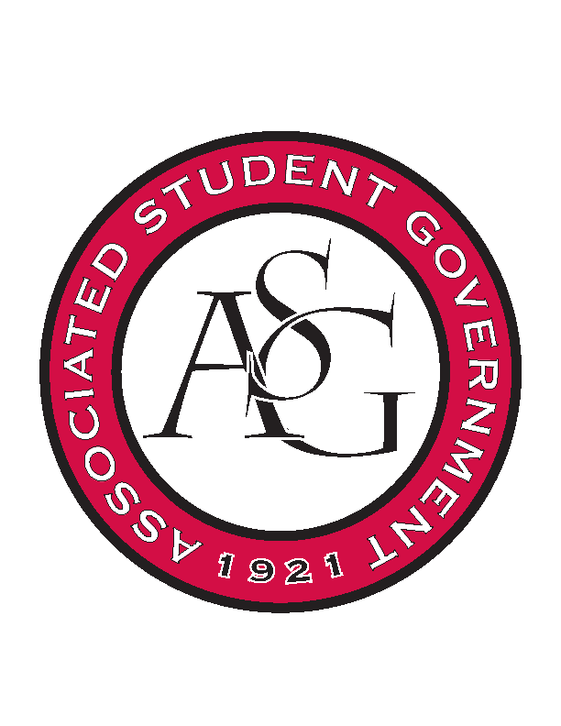
Associated Student Government

Office of Financial Affairs Meeting Agenda
May 3, 2018

- Call To Order
- Roll Call
- Approval of the Minutes
- Appeals
- Audit Reports
- Old Business
  - National Residence Hall Honorary
  - ALPFA – additional student to the same conference
  - Caribbean Student Association
  - Alpha Chi Sigma
  - Minorities in Agriculture, Natural Resources, and Related Sciences
  - Creative Writing Club
  - IEEE Power Electronics Society
  - Hispanic Law Student Association
  - Il Circolo Italiano
  - Phi Alpha Delta
  - American Institute of Architecture Students
  - Army ROTC
  - UARK Gaming – Admin Funds
  - Camp Kesem
  - Russian-Eurasian Student Organization
  - Greek Life Budget Portal - Sigma Iota Alpha Conference and Admin supplies
  - Beta Psi Omega
  - Contemporary Sculpture Society
  - UARK Gaming – Recruitment
  - Alpha Chi Sigma
  - Razorback Relay For Life
- Announcements
  - Remember to fill out your audits!
- Adjournment

